THE NEW CROPLINK SOLUTIONS FULL WEBSITE STRUCTURE

1. HOME PAGE
Sections:
- Hero Banner
– New powerful headline
– Positioning subtext
– 2 CTAs
– Moving background (fields / container loading / farm scenes)
- CropLink in 20 Seconds
– A short paragraph summarizing EXACTLY what CropLink is.
- Our Core Services Preview (9 cards)
– Each with icon + short 1-line description
– CTA: View All Services
- Our Crops (Preview Cards)
– Cashew Nuts
– Sesame
– Pigeon Peas
– Green Moong
– Cloves
– Avocado
– Spices category
– CTA: View All Crops
- Why CropLink? (New mandatory power section)
– 6 reasons
– This is where trust is created.
- Our Impact & Reach
– Countries served
– Regions covered
– Farmers/AMCOS verified
– Shipments handled
– Compliance partners
- Partnership Banner
– High-trust section for ministries, crop boards, banks, development partners
- CTA Strip
– Request Quotation
– Export Advisory
– Supplier Verification

2. ABOUT US PAGE
Sections:
- Banner
- Who We Are
- Our Purpose
- What We Believe
- Our Approach (CropLink Method)
– 7-step model from sourcing to delivery
- Our Values
- Our Strategic Direction (2025 onwards)
– Export promotion
– Value addition
– Quality & compliance
– Trade linkage
- CTA: Work With CropLink

3. SERVICES PAGE (Overview Page)
Sections:
- Banner
- Intro Statement
- Nine Service Blocks
Each with:
– Icon
– Title
– Short teaser
– CTA to full page

4. DETAILED SERVICE PAGES (9 Pages)
Each page will now have:
1. Banner
2. Strong, authoritative Overview
3. What We Do (Technical Tasks)
4. How We Serve (Method / Workflow)
5. Documents, Standards or Compliance Involved
6. Why Choose CropLink
7. CTA (Different for each service)

5. OUR CROPS PAGE (Overview Page)
Sections:
- Banner
- Intro: Tanzania’s Crop Power
- Crop Cards (10 crops)
- CTA: View Export Specs

6. INDIVIDUAL CROP PAGES (Per Crop)
Each crop page will include:
- Banner
- About the Crop
- Why Tanzania’s Quality is Superior
- Growing Regions & Maps
- Harvest Seasons & Availability Calendar
- Quality Specifications & Grading
- Global Demand & Market Trends
- How CropLink Supports Buyers (Our Position)
- Typical Shipment & Packaging Options
- CTA
Crops:
- Cashew Nuts
- Sesame Seeds
- Pigeon Peas
- Green Moong
- Chickpeas
- Sunflower Seeds
- Avocados
- Cloves
- Cardamom
- Black pepper
- Groundnuts
- Cocoa
7. MARKETS PAGE
- Regions served
- Export destination highlights
- Why buyers choose Tanzania
- Shipment standards
- CTA

8. PARTNERSHIPS PAGE
- Ministries
- Crop boards
- Regulatory partners
- Development organizations
- Banks & financial institutions
- What partnership means
- CTA

9. CONTACT PAGE
- Full details
- Form prompts
- Export inquiry prompts
- Map
- CTAs

10. FOOTER CONTENT
- Quick links
- Socials
- Compliance note
- Export disclaimer

CONTENT FOR EACH PAGE
HOME PAGE

SECTION 1: HERO BANNER
Primary Headline
Empowering Tanzania’s Agricultural Export

Positioning Subtext (stays under headline):
We help global buyers access high-quality Tanzanian crops through verified sourcing, deep quality assurance, structured documentation, and end-to-end export coordination.

Hero CTAs:
Primary CTA:
Request Export Quotation
Secondary CTA:
Explore Our Services

Hero Slide Content (Moving Background)
Suggested slides (5–6 total):

SLIDE 1: Tanzania’s Agricultural Powerhouse
Headline:
Premium crops grown naturally in fertile regions.
Subtext:
Cashew • Sesame • Pigeon Peas • Spices • Coffee • Cocoa • Sunflower • Avocado.

SLIDE 2: Verified Sourcing You Can Trust
Headline:
On-ground presence in Tanzania’s key sourcing zones.
Subtext:
We work directly with farmers, AMCOS, processors, and warehouses.

SLIDE 3: Structured Export Coordination
Headline:
Every export step, managed professionally.
Subtext:
Sourcing → QC → Documentation → Logistics → Shipping.

SLIDE 4: Quality Without Compromise
Headline:
Inspection, grading, sampling, and certification done right.
Subtext:
Protecting buyers from inconsistent quality and unreliable suppliers.

SLIDE 5: Global Buyer Support
Headline:
Clear updates, accurate documents, and reliable loading.
Subtext:
Trusted by buyers in India, UAE, Turkey, China, and Europe.

SLIDE 6: Promoting Tanzania to the World
Headline:
We elevate Tanzania’s crops on global trade platforms.
Subtext:
Building global visibility and demand for local products.

SECTION 2: Quick Overview of CropLink
CropLink Solutions Limited is a professional agribusiness and export facilitation company helping global buyers access high-quality Tanzanian crops with confidence. We combine verified sourcing, quality inspection, structured documentation, and reliable shipping coordination to ensure every shipment is consistent, compliant, and delivered with precision.

SECTION 3: OUR CORE SERVICES
Exporting agricultural products is not about finding crops alone, it is about managing dozens of moving parts with accuracy and discipline. CropLink provides a complete suite of services that bring structure, transparency, and professionalism into every stage of the export chain.
From sourcing and verification to documentation, logistics, quality control, and global promotion, our services are designed to help buyers and exporters operate with clarity and confidence.
1. Export Advisory & Consultancy
We guide exporters, investors, SMEs, and international buyers through accurate market intelligence, product selection, pricing windows, documentation sequences, and compliance requirements.
CTA: Learn More

2. Crop Sourcing & Procurement
We source, verify, purchase, and prepare crops from Tanzania’s key production regions.
Our team scouts districts, evaluates lots, negotiates prices, and ensures quality matches buyer specifications.
CTA: View Procurement Process

3. Supplier Sourcing & Verification
We help global buyers avoid risks by verifying suppliers, inspecting warehouses, reviewing documentation, assessing capacity, and confirming product traceability.
Our verification removes uncertainty from the export chain.
CTA: Verify Supplier

4. Market Linkage & Trade Facilitation
We connect verified Tanzanian suppliers with serious global buyers ensuring deals are structured, clear, and fully executable.
We bridge trust gaps and streamline communication for both sides.
CTA: Connect Now

5. Export Documentation & Compliance
We prepare all export documents with accuracy: invoices, packing lists, certificates, inspection forms, BL instructions, and export clearances.
This prevents delays, penalties, or rejections at the port.
CTA: Documentation Support

6. Logistics & Shipping Coordination
We supervise loading, sealing, fumigation, inspections, port processes, and vessel alignment ensuring every shipment is properly prepared and delivered.
You get a clean, reliable logistics workflow.
CTA: Coordinate Shipment

7. Quality Inspection & Certification
We conduct sampling, grading, moisture testing, purity checks, and prepare full quality reports. Every shipment meets international standards and buyer expectations.
CTA: Request Inspection

8. Product Branding & Global Crop Promotion
We promote Tanzanian crops globally through branding, catalogs, spec sheets, content, and trade fair representation. We position Tanzania’s products competitively in the global market.
CTA: Promote Tanzania’s Crops

9. Capacity Building & Export Training
We train farmers, SMEs, youth, processors, and exporters on practical export skills — from documentation to quality control and pricing.
We build Tanzania’s next generation of exporters.
CTA: Start Training

SECTION 4: OUR CROPS
Tanzania is home to some of the most naturally grown and highly demanded agricultural products in the world. Our role is to help global buyers access these crops reliably by sourcing directly from verified producers, ensuring consistent quality, and managing export preparation from start to finish.
Below is a preview of the crops we supply, each representing Tanzania’s agricultural strength and global relevance.
1. Cashew Nuts
Tanzania is one of the world’s leading cashew producers, known for high kernel yield, clean flavor, and naturally grown orchards. Most production comes from Mtwara and Lindi, with consistent quality preferred by processors in India, Vietnam, UAE, and Turkey.
CTA: Learn More

2. Sesame Seeds
Highly favored for purity, oil content, and natural whitening. Sourced from Dodoma, Singida, Manyoni, Kondoa, and Morogoro regions with steady annual output.
CTA: Learn More

3. Pigeon Peas
A major Tanzanian export to India and Pakistan, known for stable quality, natural drying, and good grain structure. Mostly grown in Southern Highlands and Central Tanzania.
CTA: Explore More

4. Green Moong
Popular for consistent size, color, and protein content. Tanzania’s naturally grown moong is valued in Asian and Middle Eastern markets.
CTA: Learn More

5. Chickpeas
Clean, round, and uniform chickpeas from Manyara, Dodoma, and Singida. Growing demand in India, UAE, and Pakistan.
CTA: Learn More

6. Sunflower Seeds
Naturally grown sunflower used for edible oil production. High oil content varieties sourced from Singida, Manyara, and Dodoma.
CTA: Learn More

7. Groundnuts
Redskin and runner varieties with good size and low aflatoxin levels. Demand continues to grow in Asia, Africa, and Middle Eastern markets.
CTA: Learn More

8. Avocado
Hass avocados grown in Njombe, Iringa, and Kilimanjaro prized for creaminess, oil content, and export-grade caliber.
CTA: Learn More

9. Coffee
Arabica from Kilimanjaro, Mbeya, and Songwe; Robusta from Kagera. Known for rich flavor profiles sought after by specialty coffee buyers.
CTA: Learn More

10. Cocoa
Mostly from Kyela Tanzanian cocoa is aromatic, rich, and increasingly in demand from niche chocolate makers.
CTA: Learn More

11. Cloves
A premium Tanzanian spice, primarily from Zanzibar, Morogoro and Tanga. Strong aroma and high oil content put it among the best in the world.
CTA: Learn More

12. Black Pepper
Grown in Morogoro, Tanga, and Zanzibar. Warm, aromatic, and intense, ideal for premium spice markets.
CTA: Learn More

13. Cardamom
Green, aromatic cardamom with excellent flavor profile. Used heavily in Middle Eastern and Asian markets.
CTA: Learn More

14. Cinnamon
Naturally aromatic cinnamon from Zanzibar and Tanga. High in essential oils and preferred for premium spice blends.
CTA: Learn More

15. Beans (Red, Yellow, Black, Soya)
Clean, uniform beans sourced from Northern and Central Tanzania. Popular in African and global bulk markets.
CTA: Learn More
SECTION 5: WHY CROPLINK?
The export market is competitive, fast-moving, and unforgiving to mistakes. What separates CropLink is not just what we do, but how we do it through structured systems, field presence, strict quality management, transparent sourcing, and global market understanding.
Buyers trust us because we remove uncertainties, reduce risks, and deliver reliability from start to finish.
1. Deep Ground Presence
We operate across Tanzania’s major producing regions, meaning we see quality firsthand and secure the right lots.
2. Verified Suppliers Only
We work with farmers, AMCOS, processors, and warehouses that meet strict standards.
3. Professional End-to-End Export Process
We bring structure, discipline, and predictability to an often-informal market.
4. Transparent Sourcing & Pricing
Clear processes, full updates, and traceable procurement.
5. Real Market Intelligence
We understand buyer expectations, global pricing, and export windows.
6. Protecting Buyers from Risks
Quality failures, document errors, unreliable suppliers, and shipment delays, we solve these.

SECTION 6: OUR IMPACT & REACH
Our work is measurable in regions served, buyers supported, farmers connected, and shipments successfully coordinated. We are building an export ecosystem that is more reliable, more transparent, and more globally connected.
Here’s a snapshot of our reach and the progress we continue to make across Tanzania’s agricultural value chains.
Global Trade Footprint
10+ export destinations including India, UAE, Vietnam, China, Turkey, and Europe.
National Coverage
Active sourcing across Mtwara, Lindi, Singida, Dodoma, Morogoro, Tanga, Mbeya, Njombe, Manyara, and Kilimanjaro.
Farmer & AMCOS Network
1,000+ producers reached through verified networks.
Shipments Delivered
100+ shipments coordinated through reliable workflows.
Regulatory Alignment
Collaborations with crop boards, quality regulators, and port stakeholders.

SECTION 7: PARTNERSHIP BANNER
Working Together to Strengthen Tanzania’s Agricultural Exports We work alongside ministries, crop boards, regulators, financial institutions, processors, exporters, and international buyers to create a more transparent and trusted export ecosystem.
CTA: Partner With CropLink

SECTION 8: CTA STRIP
Ready to export from Tanzania with confidence?
[Request Quotation] | [Get Export Advisory] | [Verify Supplier]

ABOUT US PAGE

1. BANNER
Headline:
Connecting Tanzania’s Agriculture to the Global Market
Subtext:
We provide end-to-end export solutions that link farmers, processors, and international buyers through professional sourcing, quality assurance, documentation, and logistics coordination.
CTA:
Work With CropLink

2. WHO WE ARE
CropLink Solutions Limited is a Tanzanian agribusiness and export facilitation company dedicated to bridging Tanzania’s agricultural potential with the demands of global markets.
We operate at the intersection of sourcing, quality assurance, documentation, logistics, and trade coordination, giving buyers and exporters a trusted pathway to reliable agricultural exports.
Our work is built on deep field presence, strong partnerships, and a structured approach that brings professionalism and clarity to an industry often dominated by uncertainty.

3. OUR PURPOSE
To empower Tanzania’s agricultural value chains by creating reliable, transparent, and profitable export pathways for farmers, processors, exporters, and global buyers.
We exist to make Tanzania’s crops visible, accessible, trusted, and globally competitive.

4. WHAT WE BELIEVE
The central focus of CropLink’s work is a set of guiding principles that shape how we operate and how we deliver value.
These are the beliefs that drive our decisions, inform our partnerships, and define our commitment to Tanzania’s agricultural future. We believe that;
- Tanzania produces some of the world’s best agricultural products.
- Farmers and processors deserve direct access to global markets.
- Exporters operate better with clear systems and reliable information.
- Global buyers need partners they can trust on the ground.
- Quality, transparency, and professionalism are non-negotiable.
- Strong value chains uplift communities and strengthen the national economy.

These beliefs guide how we work, the partnerships we build, and the impact we strive to create.

5. OUR APPROACH (THE CROPLINK METHOD)
Exporting is a chain of interdependent steps, and every link must be handled with precision. Our approach brings structure, discipline, and predictability to an industry that often operates informally.
The CropLink Method outlines exactly how we execute each export from sourcing to delivery ensuring consistent results every time.
1. Market Intelligence
We track global demand, pricing windows, seasonal trends, and buyer expectations to guide sourcing and timing.
2. Verified Sourcing
We identify high-quality crops from farmers, AMCOS, processors, and warehouses across Tanzania’s major producing regions.
3. Quality Inspection
We conduct sampling, grading, moisture testing, and verification to ensure every shipment meets international standards.
4. Documentation Preparation
We manage invoices, packing lists, inspection certificates, fumigation certificates, and export clearance documents with precision.
5. Shipping Coordination
We supervise loading, sealing, fumigation, container movement, port entry, and alignment with shipping line requirements.
6. Buyer Communication
We maintain clear, timely updates with buyers to ensure expectations match delivered quality.
7. Post-Shipment Follow-Up
We provide final reports, documentation packages, and performance tracking to maintain strong long-term relationships.
This method ensures predictable, transparent, and professional exports — every time.

6. OUR VALUES
Our values reflect who we are, how we work, and the standards we uphold. They guide our conduct, shape our culture, and anchor our relationships with farmers, suppliers, regulators, buyers, and partners across the value chain. Our values lies in;
Integrity — We operate honestly, transparently, and with accountability.
Professionalism — Every step follows a structured standard.
Collaboration — We work with farmers, processors, regulators, and buyers as partners.
Excellence — Quality in process, product, and service is non-negotiable.
Sustainability — We support responsible sourcing and long-term agricultural growth.
Inclusion — We uplift farmers, youth, SMEs, and underserved value-chain actors.

7. OUR STRATEGIC DIRECTION
As Tanzania’s agricultural landscape evolves, our focus is on long-term impact and sustainable growth.
Our strategic direction outlines the priorities that will strengthen our competitiveness, expand our global reach, and deepen the value we create for farmers, exporters, and international buyers.
1. Export Promotion
Strengthen Tanzania’s reputation by actively promoting the country’s crops globally.
2. Value Addition
Support processors and upcoming industries to move beyond raw products into semi-processed and premium offerings.
3. Quality & Compliance Leadership
Improve grading, testing, moisture control, and documentation processes across value chains.
4. Trade Linkage & Market Expansion
Connect Tanzanian suppliers with reliable global buyers, investors, and processors.
5. Digital Integration
Introduce smarter systems for traceability, communication, and buyer engagement.
6. Youth & SME Empowerment
Equip the next generation with practical export skills through training and capacity building programs.

9. CTA: WORK WITH CROPLINK
A strong, simple call to action to end the page:
Ready to export from Tanzania with confidence?
Work With CropLink →

SERVICES PAGE (OVERVIEW PAGE)

1. BANNER
Headline:
Complete Export Solutions for Tanzania’s Agricultural Value Chains
Subtext:
We offer professional, end-to-end services that support exporters, processors, farmers, cooperatives, and global buyers across every stage of the export process.

INTRO STATEMENT
Exporting agricultural products requires more than finding crops, it demands reliable sourcing systems, quality management, correct documentation, and seamless logistics.
CropLink’s service ecosystem is designed to give exporters and buyers everything they need to operate with confidence, clarity, and global competitiveness.
Below is an overview of the nine core services that define how we support Tanzania’s agricultural exports.

NINE SERVICE BLOCKS (OVERVIEW CARDS)
Each block has: Icon + Title + short rich description + CTA.

1. Export Advisory & Consultancy
Strategic guidance for exporters, SMEs, investors, and global buyers on markets, pricing windows, regulations, documentation, and export readiness.
CTA: View Full Service

2. Crop Sourcing & Procurement
Professional sourcing directly from verified farmers, AMCOS, processors, and warehouses with QC, sampling, and order fulfillment included.
CTA: View Full Service

3. Supplier Sourcing & Verification
We verify suppliers with structured assessments, documentation checks, capacity reviews, and on-site inspections to ensure reliability.
CTA: View Full Service

4. Market Linkage & Trade Facilitation
We connect trustworthy Tanzanian suppliers with serious global buyers, ensuring deals are clear, fair, and executable.
CTA: View Full Service

5. Export Documentation & Compliance
Accurate and complete documentation: invoices, packing lists, certifications, inspection reports, BL instructions, and clearance packages.
CTA: View Full Service

6. Logistics & Shipping Coordination
Supervision of loading, fumigation, inspection, port entry, container movement, and vessel alignment — all managed professionally.
CTA: View Full Service

7. Quality Inspection & Certification
Sampling, grading, moisture tests, purity checks, and certification to ensure shipments meet buyer and international standards.
CTA: View Full Service

8. Product Branding & Global Crop Promotion
Branding, content, catalogs, and promotion of Tanzanian crops across global markets, trade fairs, and buyer platforms.
CTA: View Full Service

9. Capacity Building & Export Training
Practical training for farmers, youth, SMEs, and exporters on documentation, QC, sourcing, pricing, and export compliance.
CTA: View Full Service

DETAILED SERVICE PAGES

1️⃣ SERVICE PAGE: EXPORT ADVISORY & CONSULTANCY
Banner:
Expert Guidance for Clear, Profitable & Compliant Export Decisions

Overview (Strong & Authoritative)
Exporting is a high-stakes activity whereby mistakes cost money, time, and reputation.
CropLink provides strategic advisory rooted in real market intelligence, on-ground sourcing experience, and hands-on shipment management.
We guide exporters, processors, cooperatives, SMEs, and global buyers on how to navigate markets, choose the right crops, meet international standards, and operate profitably in Tanzania’s competitive export landscape.
Our consultancy eliminates uncertainty and gives you the clarity, structure, and insight needed to succeed.

What We Do
- Market analysis and global demand intelligence
- Price forecasting and seasonality mapping
- Crop selection and export viability assessment
- Export readiness audits for SMEs
- Advisory on compliance, documentation, and workflow standards
- Destination-country requirements guidance
- Packaging and labeling recommendations
- Investment and sourcing strategy formulation
- Risk assessment and mitigation planning
- Advisory for foreign buyers entering Tanzania

How We Serve
- Diagnostic Session: Understand goals, products, and market needs
- Market Scan: Global pricing windows, competitive origins, demand cycles
- Operational Blueprint: Sourcing plan, QC plan, documentation plan
- Cost Simulation: Realistic expenses, margins, competitiveness mapping
- Compliance Guidance: Documents required, inspections, sequencing
- Execution Roadmap: Step-by-step export plan
- On-going Advisory: Continuous support as markets evolve

Documents, Standards & Compliance Involved
- Export workflow requirements
- Basic packaging & labeling standards
- Documentation sequencing (invoice → packing list → inspection → clearance)
- Quality expectations per crop (KOR, purity, moisture, FM %)
- Buyer-based compliance guidelines

Why Choose CropLink
- Advisory backed by real field operations, not theory
- Deep understanding of what global buyers actually want
- Direct exposure to Tanzania’s sourcing zones
- Proven methodologies for minimizing risk and maximizing returns
- Clear, actionable strategies. Zero guesswork

CTA:
Request an Export Advisory Session

2️⃣ SERVICE PAGE: CROP SOURCING, PROCUREMENT & EXPORT FULFILLMENT
Banner:
Reliable Sourcing, Verified Procurement & Seamless Export Execution

Overview
Sourcing crops in Tanzania requires accuracy, field intelligence, and strong supplier networks. CropLink provides a full-spectrum sourcing service: we identify, assess, buy, prepare, and export crops on behalf of international buyers or exporters.
Our presence in key producing zones ensures transparent procurement, consistent quality, and structured execution from farm to port. We eliminate guesswork and deliver a reliable, traceable sourcing experience.

What We Do
- Field scouting and sourcing in major crop-producing regions
- Supplier identification and verification
- Sample collection, grading, and quality testing
- Negotiation and lot reservation
- Buying on behalf of clients
- Warehouse handling and stacking supervision
- Export preparation: bagging, labeling, weighing
- Container loading, sealing, and fumigation coordination
- Shipment documentation and inspection management

How We Serve
- Receive buyer specs (grade, moisture, packaging, tonnage)
- Identify suitable sourcing zones
- Verify suppliers and available lots
- Negotiate, purchase, and reserve cargo
- Conduct QC tests (moisture, FM, purity, grading)
- Arrange packaging and warehouse preparation
- Supervise loading & sealing of containers
- Coordinate fumigation, inspection & documentation
- Deliver export-ready shipment to shipping line

Documents, Standards & Compliance Involved
- Pre-export inspection requirements
- Moisture & grading parameters
- Packaging & labeling requirements
- Fumigation and SPS checks
- Export documentation set (invoice, packing list, certificates)

Why Choose CropLink
- Strong on-ground sourcing presence
- Ability to purchase on behalf of clients transparently
- Technical expertise in crop quality assessment
- Reliable end-to-end export process
- Protects buyers from poor-quality shipments and unreliable suppliers

CTA:
Place a Procurement Order

3️⃣ SERVICE PAGE: SUPPLIER SOURCING & VERIFICATION
Banner:
Trusted Supplier Verification for Guaranteed Reliability

Overview
In Tanzania’s agricultural sector, supplier credibility varies widely. CropLink ensures you work ONLY with verified, capable, and compliant suppliers. We assess documents, capacity, warehouses, operational systems, and historical performance.
Our verification prevents fraud, inconsistency, and low-quality shipments.

What We Do
- Review company registration & legal documents
- Evaluate tax, operations, and export readiness
- Physical warehouse and factory inspections
- Assess storage, hygiene, and handling conditions
- Test product samples and check actual inventory
- Confirm production or sourcing capacity
- Prepare a detailed supplier verification report

How We Serve
- Collect supplier information
- Conduct documentation review
- Perform site inspection
- Evaluate product quality and stock
- Produce supplier capacity report
- Approve or reject supplier based on standards
- Facilitate introductions only for verified suppliers

Documents, Standards & Compliance Involved
- Registration documents
- Warehouse standards
- Handling & hygiene requirements
- Basic export-readiness standards
- Traceability requirements

Why Choose CropLink
- Prevents costly supplier mistakes
- Ensures partnership with credible and capable producers
- Transparent, structured verification
- Protects your money, time, and reputation

CTA:
Verify a Supplier

4️⃣ SERVICE PAGE: MARKET LINKAGE & TRADE FACILITATION
Banner:
Connecting Verified Tanzanian Suppliers With Global Buyers

Overview
CropLink acts as a bridge between Tanzania’s producers and international buyers.
We ensure deals are structured, transparent, and executable with clear expectations for both sides.
Our role is to reduce communication gaps, ensure alignment, and facilitate smooth transactions.

What We Do
- Buyer-seller matching
- Supplier credibility checks
- Negotiation support and guidance
- Alignment of quality, packaging & documentation
- Deal structuring
- Shipment coordination support
- Resolution of operational bottlenecks

How We Serve
- Understand buyer needs
- Identify suitable verified suppliers
- Facilitate introductions
- Coordinate negotiation and agreement terms
- Align product, quality, packaging, and timeline
- Support execution until shipment is complete

Documents, Standards & Compliance Involved
- Purchase agreements
- Quality expectations per crop
- Packaging and labeling standards
- Basic export documentation

Why Choose CropLink
- Strong networks across Tanzania
- Real-time knowledge of supplier capability
- Neutral, trusted facilitator
- Helps avoid misunderstandings and misaligned expectations

5️⃣ SERVICE PAGE: EXPORT DOCUMENTATION & COMPLIANCE
Banner:
Accurate, Complete, and Compliant Documentation for Smooth Export Flow

Overview
Documentation is the backbone of every successful export. One missing detail, one wrong code, or one delayed certificate can stop your shipment at the warehouse, the port, or even the destination country.
CropLink manages the entire documentation and compliance sequence with precision ensuring that your export file is complete, accurate, and fully aligned with requirements from inspectors, shipping lines, clearing agents, regulators, and international buyers.
We eliminate errors, miscommunication, and delays by preparing documents the way global buyers expect and regulators approve.

What We Do
- Prepare commercial documents (Invoice, Packing List, Specification Sheet)
- Coordinate pre-export inspections required for crops
- Manage issuance of Certificates (Origin, Fumigation, Phytosanitary, Weight & Quality reports)
- Align documentation with shipping line requirements (BL instructions, VGM, SI)
- Ensure sequencing follows export rules
- Work with clearing agents for final export clearance
- Compile the complete export file for buyer submission
- Review documents against contract terms and Incoterms
- Verify weights, counts, crop descriptions, HS codes & packaging details
- Ensure compliance with destination-country import standards

How We Serve
- Collect shipment details from supplier or buyer
- Prepare commercial documents with accurate product information
- Arrange pre-export inspections and verification steps
- Coordinate certification (SPS, fumigation, origin, weight, etc.)
- Submit documents to clearing agent & shipping line
- Cross-check BL draft with buyer’s requirements
- Compile final export file ready for buyer or bank submission

Documents, Standards & Compliance Involved
- Invoice & Packing List
- Inspection Certificate
- Phytosanitary Certificate
- Fumigation Certificate
- Certificate of Origin
- VGM (Verified Gross Mass)
- Bill of Lading Instructions & Draft
- Export clearance files
- Crop quality & packaging standards
- Destination-country requirements

Why Choose CropLink
- Zero-error approach to documentation
- Deep understanding of document sequences and export workflows
- Prevents costly delays, demurrage, and compliance penalties
- Ensures buyers receive clean, professional, and accurate documents
- Aligns every export step with shipping line and port timelines

CTA:
Get Export Documentation Support

6️⃣ SERVICE PAGE: LOGISTICS & SHIPPING COORDINATION
Banner:
Whole Coordination From Warehouse to Vessel

Overview (Deep, Rich, Authoritative)
Coordinating the logistics of agricultural exports requires precision. Crops must be sourced, verified, packaged, loaded, sealed, fumigated, inspected, and delivered to port, all within strict timelines that match shipping schedules.
CropLink oversees every step of this chain. We manage operational timings, ensure quality is preserved, supervise loading procedures, coordinate with inspectors, and align shipments with shipping line deadlines. Our coordination protects both cargo integrity and buyer timelines.

What We Do
- Plan and schedule shipment timelines
- Arrange inland transport from warehouse to port
- Supervise container loading, weighing, sealing
- Coordinate fumigation processes
- Oversee pre-shipment inspections
- Confirm container readiness for port entry
- Manage documentation with shipping lines
- Ensure SI (Shipping Instructions) and VGM submissions
- Monitor vessel schedules and port updates
- Provide loading reports and final dispatch confirmation
- Ensure cargo integrity during handling

How We Serve
- Shipment Planning aligning with timelines, requirements, and coordination
- Warehouse Preparation from stacking, bagging, labeling, weighing
- Loading Supervision that gives photos, videos, and seal confirmation
- Fumigation & Inspections that is coordinated and verified
- Port Delivery such as gate pass, terminal entry, staging
- Shipping Line Documentation from SI, VGM, and BL instructions
- Vessel Loading Confirmation that provides final updates and reports

Documents, Standards & Compliance Involved
- Loading Reports
- Seal Confirmation Records
- Fumigation Certificate
- Inspection Certificate
- Weighbridge Report
- Gate Pass & Terminal Documents
- VGM, SI, BL Instructions

Why Choose CropLink
- Strong coordination reduces delays and minimizes waste
- Professional loading supervision protects product quality
- Expertise in dealing with port processes and timelines
- Transparent communication for both shipper & buyer
- Reliable, predictable logistics execution every time

CTA:
Coordinate Your Shipment With CropLink

7️⃣ SERVICE PAGE: QUALITY INSPECTION & CERTIFICATION
Banner:
Standardized Sampling, Testing & Certification You Can Trust

Overview (Full Richness Maintained)
Quality determines whether a shipment succeeds or fails in the global market.
CropLink ensures every lot meets international standards through structured, professional quality inspection processes.
We conduct sampling, moisture testing, foreign matter checks, grading, purity verification, and final certification. Our inspections protect buyers from low-quality shipments and give exporters a strong foundation of trust.

What We Do
- Pre-shipment sampling and grading
- Moisture content testing
- Foreign matter (FM) analysis
- Kernel Outturn Ratio (KOR) analysis for cashews
- Purity tests for sesame, legumes, spices
- Color and grain uniformity checks
- Laboratory testing (where required)
- Inspection coordination with authorities
- Issuance of detailed quality reports
- Certification alignment with buyer specs

How We Serve
- Sample Collection, collected scientifically from various points
- Initial Assessment from grading, moisture, and FM checks
- Lab Testing for aflatoxin, oil content, purity, etc.
- Official Inspection that is arranged with relevant authorities
- Final Quality Report that is detailed, transparent, buyer-ready
- Approval For Shipment only approved lots proceed to loading

Documents, Standards & Compliance Involved
- Quality Analysis Report
- Moisture and FM Sheets
- Lab Certificates (when needed)
- Pre-Shipment Inspection Certificate
- Acceptance Confirmation

Why Choose CropLink
- Ensures consistency, reliability, and buyer satisfaction
- Protects cargo value and reduces rejection risk
- Transparent, evidence-based inspection processes
- Strong reputation with international buyers

CTA:
Request Quality Inspection

8️⃣ SERVICE PAGE: PRODUCT BRANDING & GLOBAL CROP PROMOTION
Banner:
Building Global Visibility for Tanzania’s Agricultural Products

Overview
Tanzania’s crops are exceptional, but global markets don’t always know it.
CropLink strengthens the visibility, demand, and competitiveness of Tanzanian agricultural products through strategic branding and global promotion. We create compelling product identities, export catalogs, spec sheets, videos, photography, and promotional content.
We represent Tanzania’s crops on international trade platforms and craft targeted buyer messaging that positions our products as premium and trustworthy.

What We Do
- Crop-specific branding concepts
- Commodity photography & video production
- Export catalogs & product specification sheets
- International marketing campaigns
- Digital ads targeting buyers & processors
- Trade fair representation and product showcases
- Storytelling for Tanzania’s origin and agricultural heritage
- Buyer-focused promotional materials (presentations, brochures, etc.)
- Global awareness messaging

How We Serve
- Identify Crop Value & Unique Qualities
- Develop Branding & Storyline
- Produce Promotional Materials
- Launch Digital & Buyer Outreach Campaigns
- Represent Products at International Platforms
- Support Exporters with Buyer Communication Assets

Documents, Standards & Compliance Involved
- Product catalogs
- Specification sheets
- Packaging guidelines
- Promotional assets
- Digital content & trade fair materials

Why Choose CropLink
- Deep understanding of Tanzania’s crops and markets
- Clear, professional communication targeted at real buyers
- Ability to position Tanzania competitively on the global stage
- Strengthens both national and exporter-level brand equity

CTA:
Promote Tanzanian Crops Globally

9️⃣ SERVICE PAGE: CAPACITY BUILDING & EXPORT TRAINING
Banner:
Equipping the Next Generation of Exporters With Practical Skills

Overview (Richest Version — Zero Weakness)
Sustainable export growth requires skilled people. CropLink provides practical, experience-driven training that equips farmers, processors, cooperatives, youth, SMEs, and exporters with real, actionable export skills.
Our training programs go beyond theory, we teach using real cases, real documents, real shipping scenarios, and real market data. We empower more Tanzanians to participate meaningfully in global trade.

What We Do
- Export process training (A–Z workflow)
- Documentation training (invoice, packing list, certificates, BL)
- Quality & grading training for various crops
- Warehouse handling & crop preservation
- Export pricing & cost analysis
- Sourcing & procurement essentials
- Global market expectations
- SME training for export readiness
- Youth mentorship for entry into export careers
- Custom training for institutions & cooperatives

How We Serve
- Needs Assessment to understand gaps & capacities
- Curriculum Design that is tailored to crop, industry, or institution
- Practical Sessions that bring hands-on demonstrations & exercises
- Case Studies that are based on real CropLink operations
- Resource Materials such as guides, samples, worksheets
- Follow-Up Support to ensure continuous learning & improvement

Documents, Standards & Compliance Involved
- Training manuals & handouts
- Sample export documents
- QC guides & checklists
- Compliance outlines
- Market intelligence briefs

Why Choose CropLink
- Training based on real operations, not theory
- Practical, simple, and highly actionable content
- Helps SMEs, youth, and processors build real export capability
- Strengthens entire value chains, not just individuals

CTA:
Join CropLink Training Programs

OUR CROPS OVERVIEW PAGE

BANNER
Headline:
Tanzania’s Finest Agricultural Products — Verified and Delivered Globally
Subtext:
We supply high-quality Tanzanian crops sourced directly from farmers, AMCOS, processors, and verified warehouses backed by strict quality assurance and seamless export coordination.
CTA:
View Export Specifications

INTRO: TANZANIA’S CROP POWER
Tanzania is one of Africa’s most naturally fertile agricultural hubs, producing globally demanded crops such as cashew, sesame, pigeon peas, spices, coffee, cocoa, sunflower, and legumes.
CropLink make these products accessible to global buyers through verified sourcing, quality inspection, accurate documentation, and professional export execution.
Below is an overview of the crops we supply, each representing the best of Tanzania’s agricultural potential.

CROP CARDS (FULL PREMIUM, RICH OVERVIEW)
Here is a preview of ALL crops CropLink supplies — each with a 3–4 line strong description, not the short teaser type.

1. Cashew Nuts (RCN & Kernels)
Tanzania is globally recognized for premium cashew nuts with high kernel yield, natural flavor, and strong nut count.
Sourced mainly from Mtwara, Lindi, and Tanga, our cashews meet international grading and moisture standards.
Preferred by buyers in India, Vietnam, UAE, Turkey, and Europe.
CTA: View Cashew Specifications

2. Sesame Seeds
Our natural sesame comes from Dodoma, Singida, Manyoni, Kondoa, and Morogoro — regions known for high purity, strong aroma, and excellent oil content.
Tanzania’s sesame is especially valued in India, Turkey, UAE, and China for its color consistency and naturally low chemical use.
CTA: View Sesame Specifications

3. Pigeon Peas, Green Moong and Chickpeas
Tanzania’s chickpeas and green moong beans are appreciated for their bright color, high protein levels, and firmness. Clean, naturally dried, and uniform in size.
We source from the Southern Highlands and Central Tanzania, ensuring consistent grain structure and color.
CTA: View Pigeon Peas Specifications

4. Sunflower Seeds
Grown in Singida, Manyara, and Dodoma, Tanzania’s sunflower seeds are known for high oil content and clean harvesting methods.
They support both domestic and international edible oil production.
CTA: View Sunflower Specifications

5. Groundnuts (Peanuts)
Our redskin and runner-type groundnuts are sourced from regions with stable soils and favorable growing climates.
They show low aflatoxin levels and reliable kernel uniformity, making them ideal for food processors and exporters.
CTA: View Groundnut Specifications

6. Avocado (Hass)
Tanzanian Hass avocados from Njombe, Kilimanjaro, and Iringa offer rich flavor, high creaminess, and excellent oil content.
They are fast becoming a preferred export to Europe, Middle East, and Asia.
CTA: View Avocado Specifications

7. Coffee (Arabica & Robusta)
Tanzania’s coffee varieties especially Arabica from Kilimanjaro, Mbeya, and Songwe are renowned for balanced acidity, aromatic sweetness, and specialty-grade profiles.
Robusta from Kagera offers bold character ideal for espresso blends.
CTA: View Coffee Specifications

8. Cocoa
Sourced primarily from Kyela, Tanzania’s cocoa is fragrant, clean, and naturally grown highly valued by specialty chocolate makers for its flavor depth and quality potential.
CTA: View Cocoa Specifications

9. Cloves
Tanzania’s cloves, particularly from Zanzibar, are among the strongest globally in aroma and oil content. They are preferred by spice processors, essential oil manufacturers, and exporters worldwide.
CTA: View Clove Specifications

10. Black Pepper
We supply aromatic black pepper from Morogoro, Tanga, and Zanzibar appreciated for its warm, intense flavor and exceptional pungency.
CTA: View Black Pepper Specifications

11. Cardamom and Cinnamon
Tanzania produces naturally sweet, aromatic cinnamon and cardamom that is clean, aromatic, and bright in color with high essential oil content. Increasingly demanded by spice packers and tea manufacturers globally.
CTA: View Cardamom and Cinnamon Specifications

12. Beans (Red, Yellow, Black, Soya)
Tanzanian beans are known for their uniformity, good hydration, and clean harvesting.
They serve both bulk export markets and food industries across Africa and Asia.
CTA: View Bean Specifications

CASHEW NUTS (RCN & KERNELS) — FULL CROP PAGE

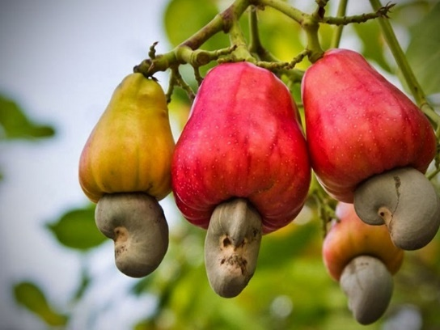

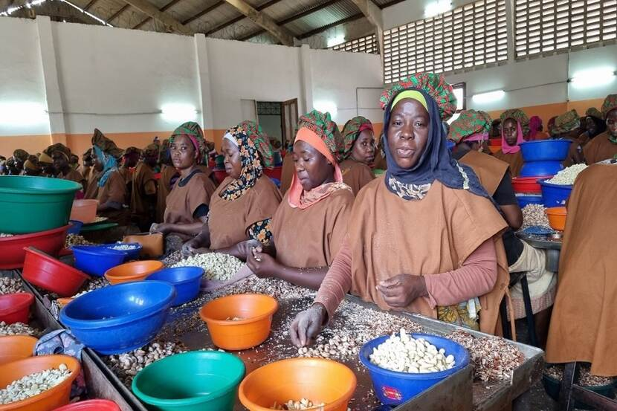

BANNER
Headline:
Premium Tanzanian Cashew Nuts with High KOR, Strong Flavor, Global Demand
Subtext:
CropLink supplies high-quality Raw Cashew Nuts (RCN) and cashew kernels sourced responsibly from Tanzania’s top producing regions with strict grading, verified moisture levels, and standardized export preparation.
CTA:
Request Cashew Quotation

ABOUT CASHEW NUTS
Tanzania is one of the world’s leading producers of high-quality cashew nuts, known for excellent Kernel Outturn Ratio (KOR), consistent nut size, natural flavor, and clean cultivation practices.
Our cashew nuts are sourced from the southern belt, the heart of Tanzania’s cashew ecosystem where favorable soils, warm temperatures, and long sunlight hours produce nuts of superior quality.
Tanzanian cashews are preferred globally for:
- High KOR (48–54 depending on region)
- Low moisture levels
- Strong nut count (W160, W180, W210, W240, W320)
- Distinctive natural sweetness
- Reduced chemical use due to natural conditions
CropLink ensures buyers access clean, well-dried, professionally handled cashew lots suitable for processing and retail markets worldwide.

WHY TANZANIA’S CASHEW QUALITY IS SUPERIOR
Tanzania’s competitive advantage is driven by:
1. Favorable Climate & Soil
Warm coastal weather increases kernel density and flavor richness.
2. Natural & Low-Chemical Farming
Most cashews are grown by smallholder farmers using natural methods.
3. High KOR Levels
Regions like Mtwara and Lindi consistently produce nuts with strong kernel yields.
4. Reliable Post-Harvest Drying
Traditional sun-drying and improved warehouse handling keep moisture below export thresholds.
5. Large Harvest Volumes
Tanzania produces over 230,000+ tons annually, ensuring strong export availability.
6. Clean, Distinctive Taste
Tanzanian cashews are prized for their creamy, full-bodied flavor.

GROWING REGIONS & MAPS
The best Tanzanian cashews come from:
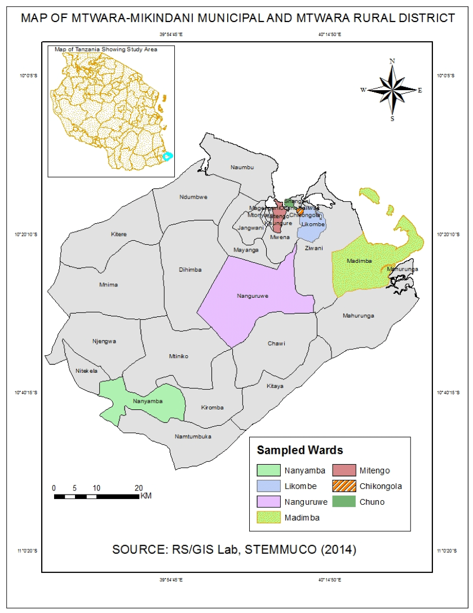
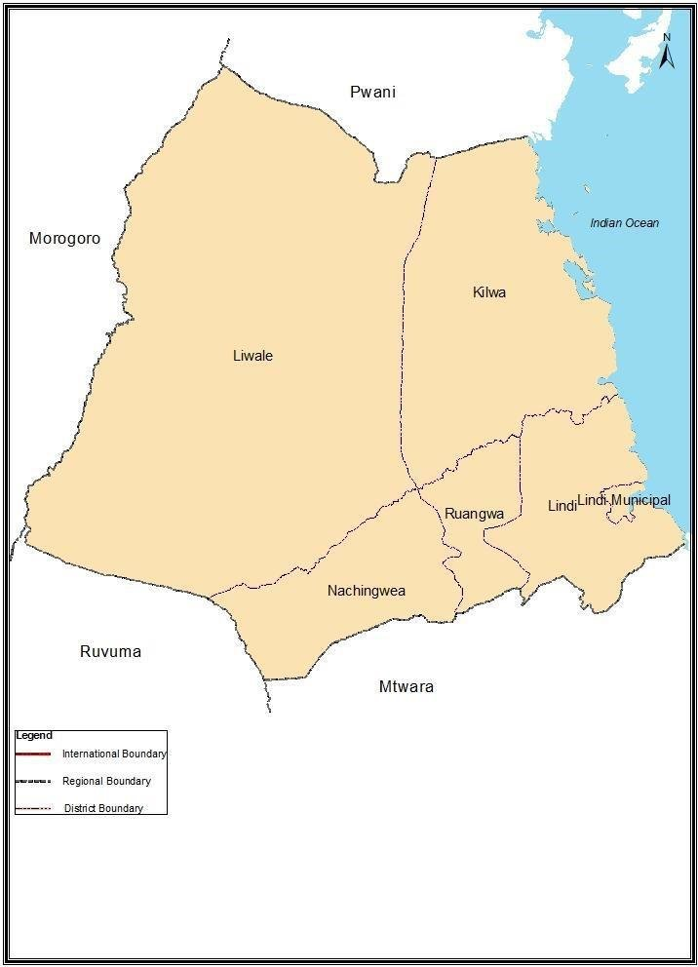
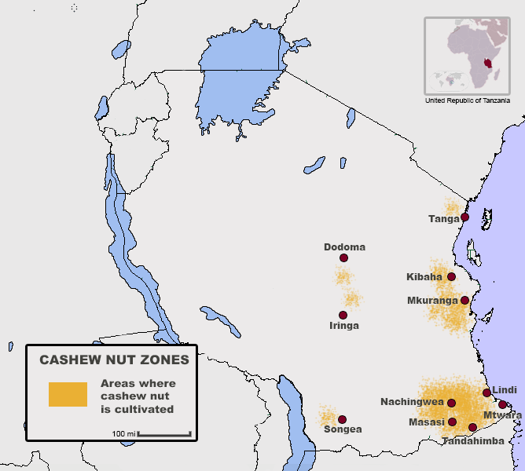

Primary Regions:
- Mtwara (highest KOR levels, premium sizes)
- Lindi (large volumes, uniform grain)
- Tandahimba
- Newala
- Ruangwa
- Kilwa
Secondary Regions:
- Tanga
- Coast Region (Pwani)
- Ruvuma
These territories produce cashews with excellent drying conditions, stable kernels, and strong processing yields.

HARVEST SEASONS & AVAILABILITY
Main Harvest Season: Tanzania
- November – January (Peak harvest)
- February – March (Late harvest)
Best Buying Window:
December – February when volume, quality, and pricing are optimal.
Availability Calendar:
Month | Availability
January | High
February | Very High
March | Moderate
April – October | Off Season
November | Early Movement

QUALITY SPECIFICATIONS & GRADING
CropLink supplies according to international grading standards.
RCN (Raw Cashew Nuts) Export Specs
- KOR: 48–54 lbs
- Nut Count: 170–200 per kg
- Moisture: ≤ 10%
- Foreign Matter (FM): ≤ 2%
- Defective Nuts: ≤ 8%
- Admixture: ≤ 1%
Cashew Kernels (if required):
- W160 and W180 (Premium large white kernels)
- W210
- W240
- W320 (most demanded globally)

We provide both raw nuts and kernels depending on buyer needs.

GLOBAL DEMAND & MARKET TRENDS
Major importing countries include:
- India
- Vietnam
- China
- UAE
- Turkey
- Europe (Netherlands, Germany, UK)
- USA (for kernels)
Trends driving demand:
- Growth in healthy snack markets
- Increased processing capacity in India & Vietnam
- Rising demand for premium kernel grades
- Expansion of artisanal nut packaging brands
- Growth in Middle Eastern snack and confectionery sectors

Tanzanian cashews remain one of the most stable and premium origins globally.

HOW CROPLINK SUPPORTS BUYERS (OUR POSITION)
CropLink acts as the buyer’s trusted on-ground partner, ensuring professional sourcing and export execution.
We provide:
- Verified sourcing from AMCOS, processors & warehouses
- Pre-purchase samples & QC updates
- Real-time videos and photos of lots
- Accurate moisture, nut count & KOR reporting
- Supervision of bagging, stacking & weighing
- Loading inspection with photos, videos & seal numbers
- Full documentation set (Invoice, PL, COO, Fumigation, Phyto, PSI)
- Transparent communication throughout

Our job is simple:
You get high-quality cashews, sourced properly, verified thoroughly, and shipped professionally.

TYPICAL SHIPMENT & PACKAGING OPTIONS
Packaging Options:
- 80 kg jute bags (standard)
- 50 kg bags (on request)
- Jumbo bags (corporate buyers)
Container Capacities:
- 1×20 ft container: 18–19 MT
- 1×40 ft container: 26–27 MT
Shipment Types:
- FCL (Full Container Load)
- Multi-container contracts
- Seasonal sourcing contracts

CTA
Ready for pricing, availability, and samples?
Request Cashew Quotation →

SESAME SEEDS — FULL CROP PAGE

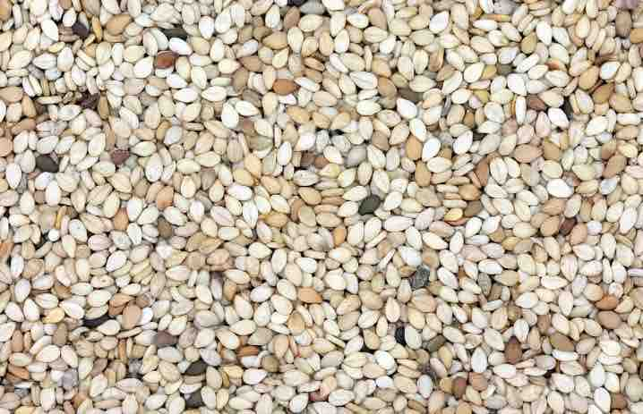
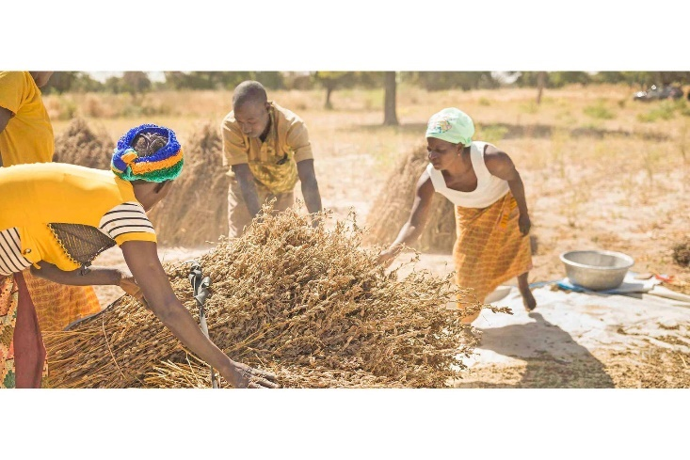
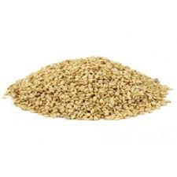

1. BANNER
Headline:
High-Purity, Naturally Grown Tanzanian Sesame for Global Markets
Subtext:
We supply premium-grade white and mixed sesame sourced directly from Tanzania’s top producing zones that are verified for purity, moisture, color, and oil content, with fully professional export preparation.
CTA:
Request Sesame Quotation

ABOUT SESAME SEEDS
Tanzania produces some of the cleanest, naturally grown sesame seeds globally.
Favored for their high oil content, strong aroma, and consistent color, Tanzanian sesame is widely demanded by processors, tahini manufacturers, oil mills, snack producers, and spice buyers across Asia, Europe, and the Middle East.
CropLink sources sesame from verified farmers, AMCOS, and processors operating in the country’s sesame belt ensuring quality that is consistent, reliable, and export-ready.
Tanzanian sesame stands out because it is naturally cultivated, mostly non-GMO, and dried under optimal sunlight conditions that preserve flavor and oil profile.

WHY TANZANIA’S SESAME IS SUPERIOR
1. Naturally Grown (Low Chemical Use)
Most farmers use traditional, chemical-minimal production methods making the crop cleaner and more preferred by processors.
2. High Oil Content
Tanzanian sesame typically shows 48–52% oil, one of the best in Africa.
3. Strong Aroma & Freshness
Sun-drying and natural handling preserve flavor intensity.
4. Color Consistency
Especially from Singida & Manyoni, highly appreciated in India, Turkey, and the Middle East.
5. Reliable Harvest Volumes
Production remains strong across central zones, ensuring steady supply.

GROWING REGIONS & MAPS
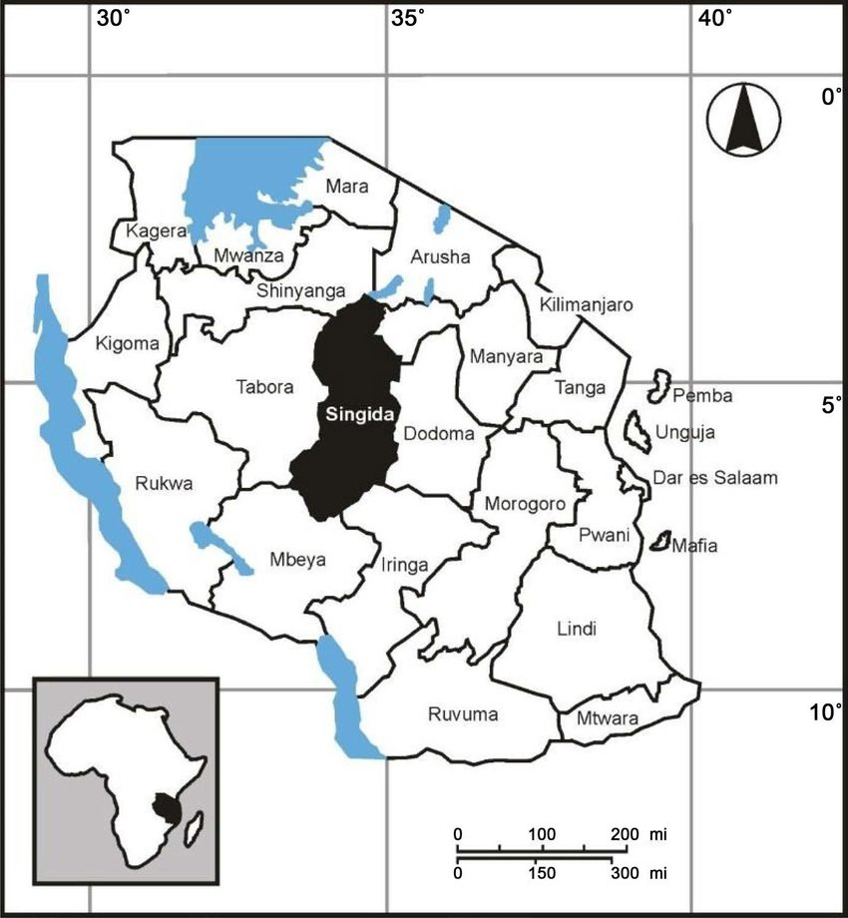
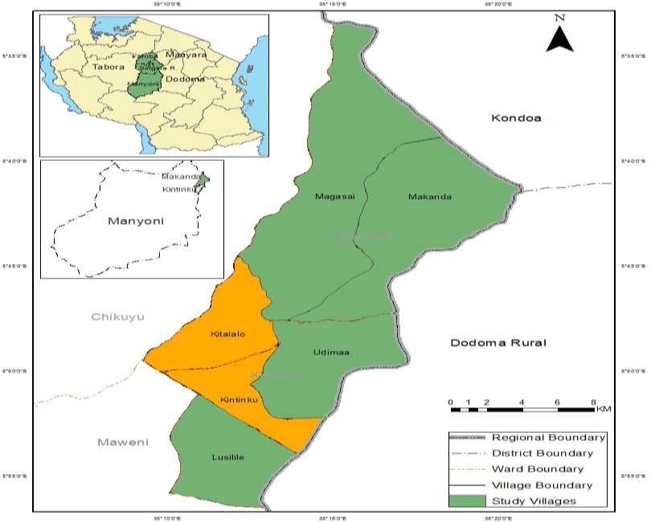
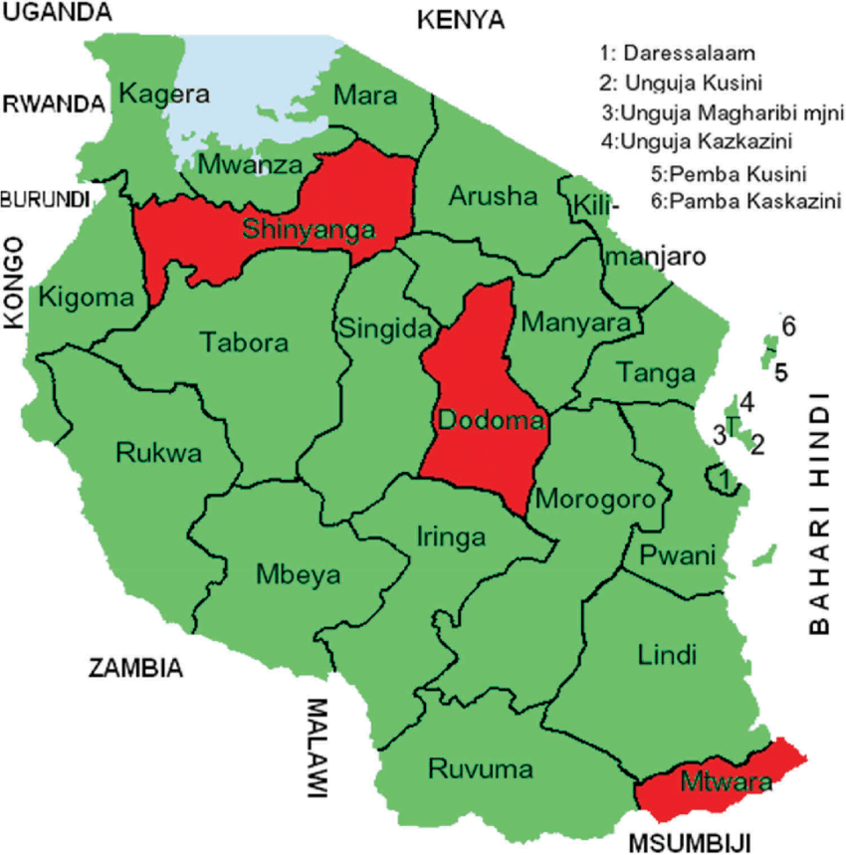

Major Sesame Producing Regions:
- Singida (Premium white sesame; high purity)
- Manyoni (Clean, uniform grains; excellent drying climate)
- Kondoa
- Dodoma Rural
- Iramba
- Tabora
- Shinyanga (mixed sesame varieties)
- Morogoro & Kilosa (increasing volumes)

Each region has slightly different color profiles and purity levels, giving buyers multiple quality options.

HARVEST SEASONS & AVAILABILITY
Main Season (Tanzania):
- June – September (Peak season)
- October – November (Extended supply)
Best Buying Window:
July – October
Quality is stable, moisture is low, and supply is high.
Availability Calendar:
Month | Availability
June | Early Crop
July | High
August | Very High
September | Very High
October | High
November | Moderate
December – May | Off Season

QUALITY SPECIFICATIONS & GRADING
CropLink supplies high-grade sesame aligned with international buyer requirements.
Standard Export Specs:
- Purity: 98–99%
- Moisture: ≤ 7%
- FFA: < 2%
- Admixture: ≤ 1–2%
- Oil Content: 48–52%
- Color:
  - Hulled-quality white (unhulled yet hulled-grade brightness)
  - Mixed sesame (from Shinyanga & Tabora)
  - Golden sesame (available seasonally)
Grades Available:
- Premium White (Singida & Manyoni)
- Natural White
- Mixed Sesame
- Golden Sesame
Each lot is sampled, graded, and certified before purchase and export.

GLOBAL DEMAND & MARKET TRENDS
Key Import Markets:
- India
- Turkey
- UAE
- China
- Israel
- Saudi Arabia
- Japan (small but premium segment)
Global Trends Supporting Demand:
- Growing tahini and halva industries
- Rising demand in bakery, snacks, and confectionery
- Increased use of sesame oil in Asian cuisines
- Preference for naturally grown, premium white sesame
- Strong demand for African sesame due to Asia’s processing growth

Tanzanian sesame remains competitive due to quality consistency and aroma strength.

HOW CROPLINK SUPPORTS BUYERS (OUR POSITION)
CropLink serves as your trusted on-ground sourcing and export execution partner, ensuring every step is handled professionally.
What we do for sesame buyers:
- Source directly from Singida, Manyoni, Dodoma & Morogoro
- Provide pre-purchase samples & real-time lot videos
- Conduct purity, moisture & color assessments
- Ensure proper cleaning, sorting, and bagging
- Supervise warehouse handling and weighing
- Inspect loading with photos, videos & seal confirmation
- Manage all export documentation
- Provide transparent communication throughout procurement

Your advantage:
No surprises. Just clean, consistent, export-ready sesame.

TYPICAL SHIPMENT & PACKAGING OPTIONS
Packaging:
- 50 kg PP bags (standard)
- 25 kg bags (for special markets)
- Bulk jumbo bags (on request)
Container Loading:
- 20 ft container: 19–20 MT
- 40 ft container: 26–28 MT
Shipment Types:
- Single-container contracts
- Multi-container seasonal contracts
- Bulk procurement for processors

CTA
Need pricing, samples, or current availability?
Request Sesame Quotation →

PULSES & LEGUMES
Pigeon Peas • Green Moong • Chickpeas

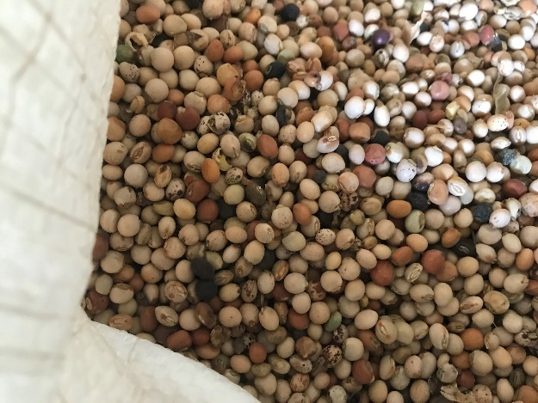
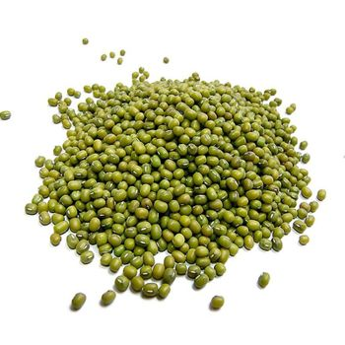
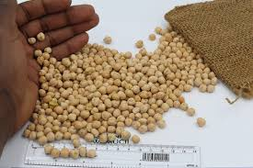

1. BANNER
Headline:
High-Quality Tanzanian Pulses for Global Food & Processing Markets
Subtext:
CropLink supplies premium pigeon peas, green moong, and chickpeas sourced from Tanzania’s top agricultural regions, fully verified for purity, moisture, grain size, and international grading standards.
CTA:
Request Pulse Prices & Specifications
ABOUT TANZANIA’S PULSES
Tanzania is a leading East African supplier of naturally grown pulses with strong demand across India, Pakistan, UAE, and global dhal processors.
Our pulses stand out for:
- Natural sun-drying
- High protein content
- Uniform grain structure
- Stable color
- Low pesticide use
- Strong cooking characteristics

CropLink ensures these pulses are sourced responsibly from cooperatives, farmers, and verified warehouses, with strict quality checks before export.

WHY TANZANIA’S PULSES OUTPERFORM OTHER ORIGINS
✔ Naturally grown, minimal chemical use
Tanzanian farmers use traditional methods that preserve flavor and cooking quality.
✔ High protein levels & strong dhal yield
Highly preferred by processors due to consistent cooking behavior.
✔ Clean sun-drying conditions
Reduces moisture and improves shelf stability.
✔ Strong grain structure
Less breakage during milling.
✔ Competitive pricing
With stable supply across regions.

⭐ 4. MAJOR GROWING REGIONS
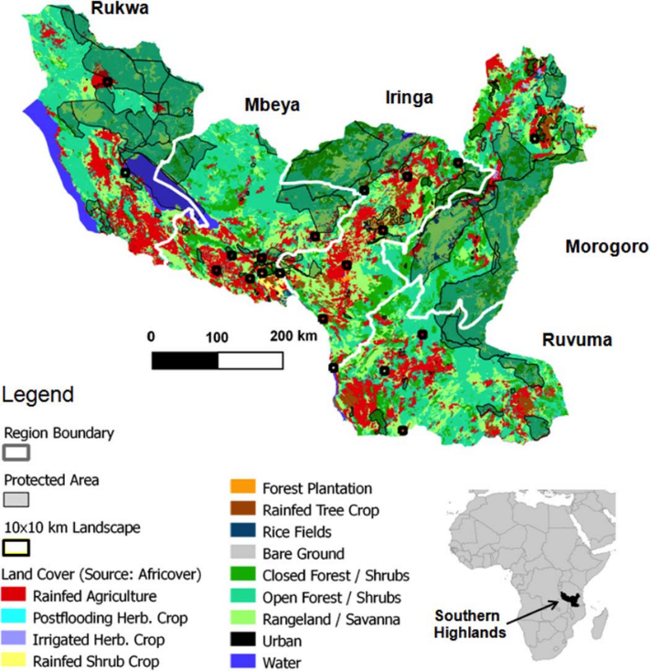
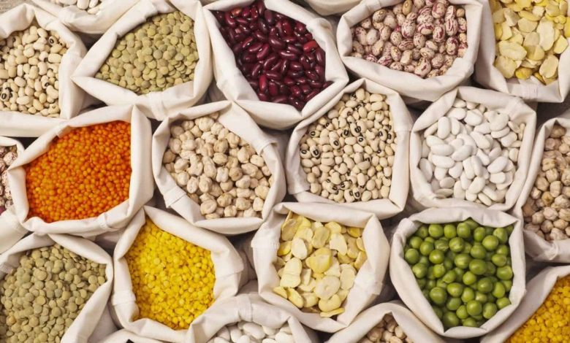

Primary Pulse-Producing Regions in Tanzania:
- Dodoma
- Manyara
- Shinyanga
- Morogoro
- Iringa
- Songwe
- Mbeya
- Ruvuma

HARVEST SEASON & AVAILABILITY (ALL THREE PULSES)
Main Harvest Season:
May – September
Peak Buying Window:
June – August
Best quality, optimal moisture, and strong availability.
Availability Calendar:
Month | Availability
May | Early Crop
June | High
July | Very High
August | Very High
September | High
October | Moderate
November–April | Off Season

INDIVIDUAL CROP SECTIONS
(Each with deep specifications)

🟡 A. PIGEON PEAS (TOOR DAL RAW MATERIAL)
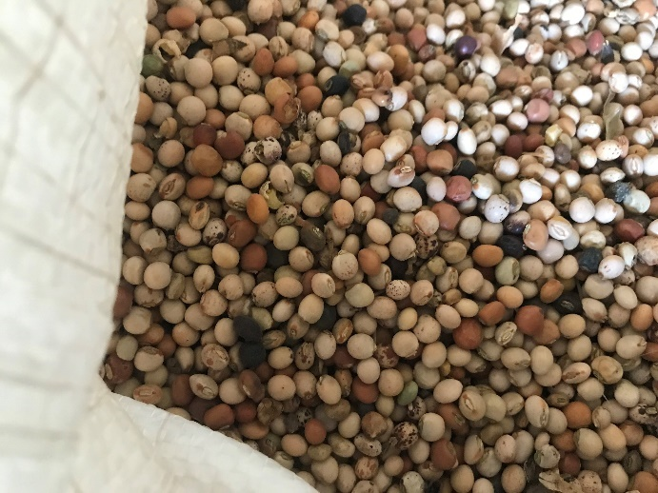
Overview
Tanzania’s pigeon peas (cream, white, and light brown varieties) are highly demanded for dhal processing in India and Pakistan. The grains are uniform, naturally dried, and hold strong shape during milling.
Specifications:
- Purity: 97–99%
- Moisture: ≤ 12%
- Admixture: 1–2%
- Color: Cream / White / Light Brown
- Size: Uniform grain, suitable for dhal splitting
- Broken: < 3%
Buyer Markets:
- India (main market)
- Pakistan
- UAE
- Nepal
- Bangladesh (seasonally)

CropLink Buyer Support:
- Pre-shipment sampling
- Grain size & color verification
- Moisture testing
- Cleaning & sorting supervision
- Loading inspection with photos/videos
- Full export documentation
CTA:
Request Pigeon Pea Prices

🟢 B. GREEN MOONG (MUNG BEANS)
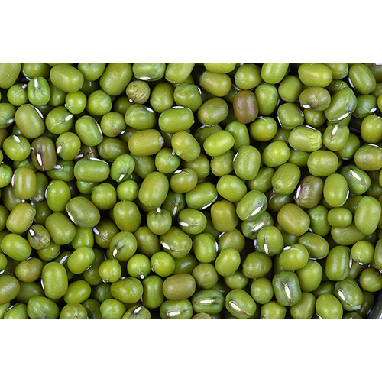

Overview
Tanzanian green moong is valued for its bright green color, high protein content, and uniform grain size, perfect for dhal, sprouting, and food processing industries.
Specifications:
- Purity: 98–99%
- Moisture: ≤ 12%
- Color: Bright green
- Admixture: < 2%
- Broken: < 3%
- Use: dhals, sprouting, flour production, snacks
Buyer Markets:
- India
- Sri Lanka
- UAE
- Indonesia
- Vietnam
CropLink Buyer Support:
- Sample provision before purchase
- Color & brightness verification
- Cleaning/sorting setup
- Loading and sealing photos
- Complete document pack
CTA:
Request Moong Pricing

🟠 C. CHICKPEAS (DESI VARIETY)
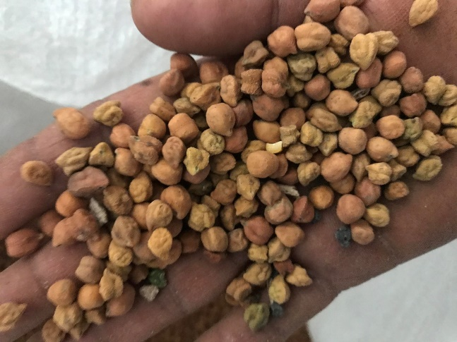

Overview
Tanzania produces high-quality desi chickpeas used for dhal (chana dhal), flour production (besan), and food ingredients. Known for stable color, good hydration, and strong grain structure.
Specifications:
- Purity: 98–99%
- Moisture: ≤ 12%
- Color: Light brown / beige (desi)
- Broken: < 2–3%
- Admixture: ≤ 1–2%
Buyer Markets:
- India
- Pakistan
- UAE
- Saudi Arabia
- South Africa
CropLink Buyer Support:
- Accurate sampling
- Purity & grain-size checking
- Supervised bagging & weighing
- Quality inspection reports
- Documentation support
CTA:
Request Chickpea Specifications

HOW CROPLINK SUPPORTS PULSE BUYERS (OUR POSITION)
CropLink acts as the trusted on-ground execution partner.
We provide:
- Verified sourcing directly from farmers, AMCOS & processors
- Real-time lot videos & photos
- Moisture & purity verification
- Sorting & cleaning supervision
- Professional loading oversight with seals recorded
- Full export documentation (COO, Fumigation, Phyto, PSI)
- Transparent communication from purchase to vessel loading
We protect buyers from:
- Moisture fraud
- Mixed grains
- Poor cleaning
- Unverified suppliers
- Bad documentation
- Delayed shipments

Your shipment leaves Tanzania clean, compliant, and exactly as requested.

PACKAGING & SHIPPING OPTIONS
Standard Packaging:
- 50 kg PP bags
- 25 kg bags (on request)
Container Loading:
- 20 ft container: 19–20 MT
- 40 ft container: 26–28 MT
Shipment Types:
- Contract-based supply
- Seasonal bulk procurement
- Mixed-container loading (multiple pulses)

FINAL CTA
Looking for current prices, samples, or shipment availability?
Request Pulse Export Offer →

SUNFLOWER SEEDS

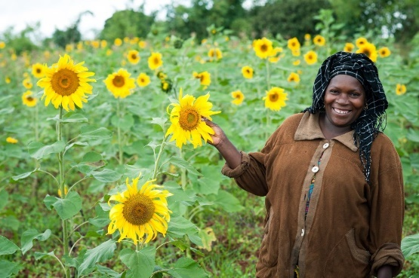
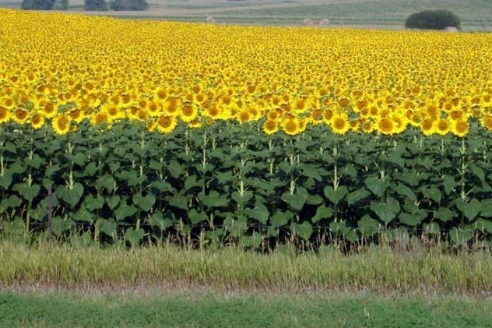


BANNER
Headline:
High-Oil Tanzanian Sunflower Seeds for Edible Oil & Industrial Use
Subtext:
CropLink supplies clean, naturally dried, and high-oil sunflower seeds sourced from Tanzania’s leading production zones with strict moisture control, impurity checks, and export-grade preparation.
CTA:
Request Sunflower Seed Prices

ABOUT THE CROP
Sunflower is one of Tanzania’s strongest agricultural value chains, supplying domestic edible oil manufacturers and international processors with high-oil, naturally grown seeds.
The country’s central regions have ideal agro-climatic conditions that produce sunflower with:
- High oil content (38–45%)
- Low moisture due to strong sun-drying conditions
- Good grain uniformity
- Low aflatoxin risk
- Strong drying climate and low post-harvest humidity

CropLink works closely with farmers, AMCOS, and processors to source consistent-quality seeds that meet the requirements of oil mills, seed crushers, snack processors, and industrial buyers.

WHY TANZANIA’S SUNFLOWER IS SUPERIOR
✔ High Oil Content
Tanzanian seeds consistently deliver 38–45% oil, making them highly profitable for oil extraction.
✔ Naturally Sun-Dried
Drying conditions across Singida & Dodoma preserve stability and reduce moisture levels.
✔ Low Aflatoxin Vulnerability
Compared to groundnuts and maize, sunflower has lower contamination risk.
✔ Stable Production Volumes
Reliable harvests across the central corridor ensure strong yearly supply.
✔ Ideal for Oil Processors
High oil levels + low impurities = predictable milling output.
✔ Clean Handling
Most farmers use manual harvesting and traditional drying, minimizing chemical contamination.

GROWING REGIONS & MAPS

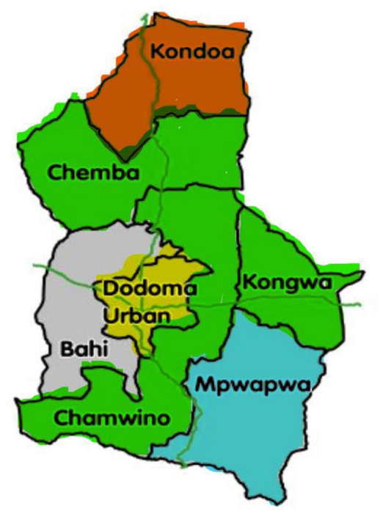
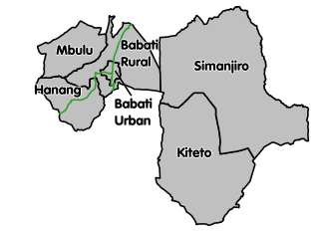
Major Sunflower Growing Regions
- Singida (highest oil content; premium lots)
- Dodoma (large volumes & stable supply)
- Manyara
- Kondoa
- Iringa
- Shinyanga
These regions produce seeds with excellent drying characteristics and strong oil extraction yields.

HARVEST SEASON & AVAILABILITY
Main Harvest Season:
May – September
Peak Quality Window:
June – August — seeds are well dried, grain is firm, and moisture is optimal for export.
Availability Calendar:
Month | Availability
May | Early Crop
June | High
July | Very High
August | Very High
September | High
October | Moderate
November–April | Off Season

QUALITY SPECIFICATIONS & GRADING
CropLink supplies export-standard sunflower seeds according to buyer requirements.
Standard Specs:
- Oil Content: 38–45%
- Moisture: ≤ 10% (ideal 7–9%)
- Impurities: ≤ 2–3%
- Broken Seeds: ≤ 3%
- Admixture: ≤ 1%
- Foreign Matter: ≤ 2%
- Color: Black / striped depending on region
- Aflatoxin: Within acceptable limits

Uses:
- Edible oil crushing
- Industrial oil production
- Animal feed (by-product cake)
- Roasting & snacks (selected grades)

We supply both crushing grade and snack-grade sunflower.

GLOBAL DEMAND & MARKET TRENDS
Top Import Markets:
- India
- Turkey
- UAE
- Saudi Arabia
- Europe (select processors)
- Regional African oil processors

Trends Driving Global Demand:
- Rising edible oil consumption globally
- Shift from palm oil to sunflower oil in many markets
- Growing popularity of natural, non-GMO oils
- Increased demand for sunflower cake for livestock feed
- Strong interest from Indian and Middle Eastern mills

Tanzania remains one of the most competitive origins in East Africa for sunflower due to quality consistency and high oil levels.

HOW CROPLINK SUPPORTS BUYERS
CropLink ensures buyers get the exact grade, moisture, and oil content requested with professional oversight at every stage.
Our Role Includes:
- Verified sourcing from Singida, Dodoma & Manyara
- Oil content testing coordination
- Moisture-level verification
- Grain uniformity assessment
- Cleaning & sorting supervision
- Bagging, weighing & warehouse preparation
- Loading inspection (photos, videos, seal numbers)
- Full documentation: COO, Phyto, Fumigation, PSI, Invoice, PL

We remove risk and guarantee predictable export performance.

PACKAGING & SHIPMENT OPTIONS
Packaging:
- 50 kg PP bags (standard)
- 25 kg bags (on request)
- Jumbo bags for bulk processors
Container Capacity:
- 20 ft container: 18–19 MT
- 40 ft container: 26–28 MT
Shipping Models:
- Single-container orders
- Multi-container seasonal supply
- Yearly procurement contracts

CTA
Ready for today’s prices, moisture levels, and oil content results?
Request Sunflower Seed Prices →

GROUNDNUTS (PEANUTS)

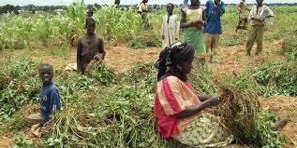
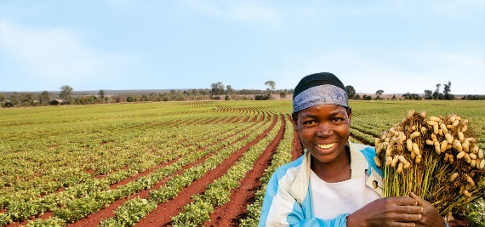
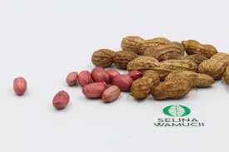

BANNER
Headline:
High-Quality, Low-Aflatoxin Tanzanian Groundnuts for Global Food Markets
Subtext:
We supply clean, naturally dried groundnuts sourced from verified farmers and AMCOS across Tanzania tested for moisture, defects, aflatoxin, and export-grade purity standards.
CTA:
Request Groundnut Quotation

ABOUT GROUNDNUTS
Tanzania produces some of East Africa’s most natural and flavorful groundnuts. With strong production in Singida, Manyara, Dodoma, Shinyanga, and Tabora, our peanuts are:
- Naturally sun-dried
- Rich in oils
- Well-formed with good kernel size
- Low in chemical exposure
- Suitable for both food and industrial uses
Groundnuts are used in confectionery, roasting, peanut butter manufacturing, oil pressing, and food ingredient industries globally.
CropLink ensures the product meets strict global safety and quality requirements especially aflatoxin limits, moisture control, and cleanliness.

WHY TANZANIA’S GROUNDNUTS ARE COMPETITIVE
✔ Naturally Grown, Low Chemicals
Grown by smallholder farmers with minimal pesticide use.
✔ Strong Flavor & Oil Profile
Ideal for roasting and peanut butter processing.
✔ Good Uniformity
Runner & redskin types with consistent grain size.
✔ Strong Drying Conditions
Central regions offer excellent sun-drying climates.
✔ Competitive Prices
Value for money compared to West African origins.
✔ Clean Handling (When Managed Properly)
Traditional farming minimizes heavy chemical residue.

GROWING REGIONS & MAPS
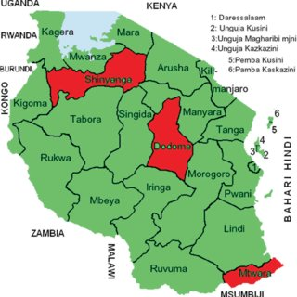


Key Groundnut-Producing Regions
- Singida
- Dodoma
- Manyara
- Shinyanga
- Tabora
- Ruvuma (secondary)

Singida & Manyara produce some of the cleanest lots with low moisture and strong kernel structure.

HARVEST SEASON & AVAILABILITY
Main Harvest Period:
May – September
Peak Buying Window:
June – August
Moisture levels are lowest & grain quality is most stable.
Availability Calendar
Month | Availability
May | Early Crop
June | High
July | Very High
August | Very High
September | High
October | Moderate
November–April | Off Season

QUALITY SPECIFICATIONS & GRADING
Groundnuts require strict compliance, so CropLink enforces buyer-grade standards.
Standard Export Specs:
- Moisture: ≤ 10% (Ideal 6–8%)
- Purity: 98%+
- Admixture: ≤ 2%
- Foreign Matter: ≤ 1%
- Broken Kernels: ≤ 2–3%
- Damaged Kernels: ≤ 3%
Aflatoxin Levels:
- Within acceptable international limits
- We coordinate both rapid test kits and lab tests (where required)
Varieties Available:
- Redskin Groundnuts
- Runner-Type Groundnuts
- Virginia-Type (small volumes)
Grades:
- Machine Cleaned
- Handpicked Selected (HPS)
- Oil Extraction Grade

GLOBAL DEMAND & MARKET TRENDS
Major Buyers:
- India
- UAE
- Saudi Arabia
- Pakistan
- Malaysia
- Indonesia
- South Africa
Trends Driving Demand:
- Growth of peanut butter and snack industries
- Rising health-conscious consumption
- High demand for redskin varieties in Asia
- Increased preference for East African origins (competitive pricing)
Tanzania’s stable production makes it a reliable supplementary origin to Malawi & Zambia.

HOW CROPLINK SUPPORTS BUYERS
Groundnuts demand precision, safety, and strict handling. CropLink works as the buyer’s on-ground execution partner, ensuring every lot meets global standards.
Our Strengths in Groundnuts:
- Verified sourcing from trusted AMCOS & farmers
- Moisture testing at warehouse level
- Aflatoxin control through sampling & lab testing coordination
- Professional cleaning & sorting supervision
- Bagging & weighing oversight
- Loading inspection with photo/video evidence
- Seal authentication & reporting
- Complete export documentation (COO, Phyto, Fumigation, PSI, Invoice, PL)

We eliminate the biggest risks:
- High moisture
- Aflatoxin
- Admixture & FM
- Poor cleaning
- Bad storage
- Documentation delays

Your shipment leaves Tanzania clean, safe, compliant, and consistent.

PACKAGING & SHIPPING OPTIONS
Packaging:
- 50 kg PP bags (standard)
- 25 kg bags (premium buyers)
- Jumbo bags (for oil mills)
Container Capacities:
- 20 ft container: 17–18 MT
- 40 ft container: 25–26 MT
Shipment Types:
- Single container
- Multi-container seasonal contracts
- Mixed containers with other pulses & oilseeds (on request)

CTA
Need today’s prices, aflatoxin reports, or sample photos?
Request Groundnut Quotation →

AVOCADO (HASS)

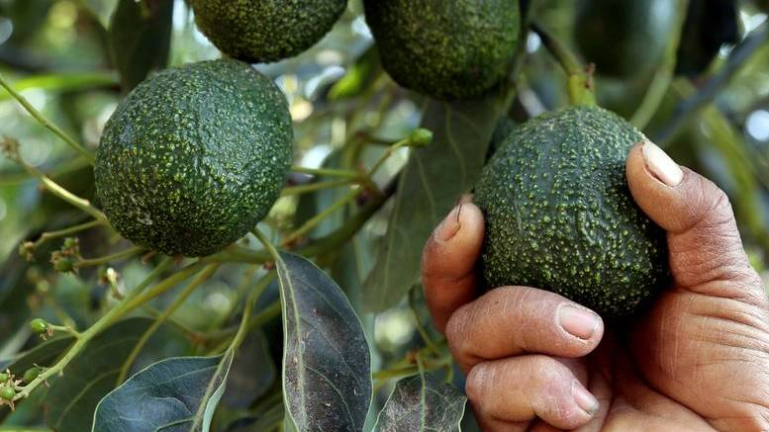
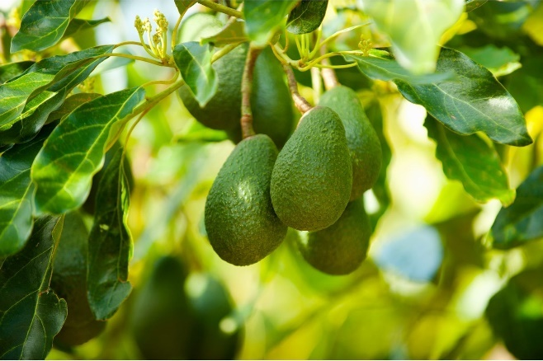
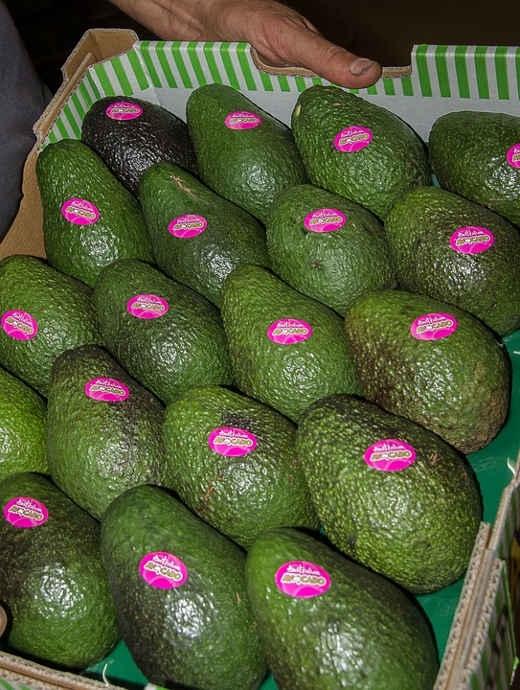

BANNER
Headline:
Premium Tanzanian Hass Avocados. Fresh, Creamy & Export-Grade
Subtext:
CropLink supplies export-certified Hass avocados grown in Tanzania’s highlands known for rich flavor, high oil content, natural creaminess, and excellent post-harvest shelf life.
CTA:
Request Avocado Export Details

ABOUT AVOCADOS
Tanzania has emerged as one of Africa’s rising stars in Hass avocado production. Grown in the cool, fertile highlands of Njombe, Iringa, Kilimanjaro, and Mbeya, Tanzanian avocados are naturally creamy, rich in oil, and favored by European, Middle Eastern, and Asian markets.
Key strengths of Tanzanian Hass:
- High oil content (18–22%)
- Creamy texture & natural flavor
- Thick peels for strong post-harvest durability
- Grown in volcanic, mineral-rich soils
- Naturally rain-fed or irrigated
- Large fruit size with consistent grading
CropLink ensures proper harvesting maturity, professional post-harvest handling, and correct export documentation ensuring the fruit reaches buyers in top condition.

WHY TANZANIA’S HASS AVOCADO IS SUPERIOR
✔ Ideal Highland Climate
Cool nights + warm days = slow maturation, which increases oil content and flavor.
✔ High Oil Content
A key indicator of premium quality fruit for export markets.
✔ Strong Shelf Life
Thick Hass skin allows long-distance shipping to Europe, Middle East, and Asia.
✔ Naturally Grown
Minimal pesticide use; most orchards follow sustainable farming practices.
✔ Competitive Fruit Size
Calibers commonly available: 12–22, depending on harvest stage.
✔ Excellent Taste Profile
Natural creaminess, balanced flavor, and attractive darkening during ripening.

GROWING REGIONS & MAPS

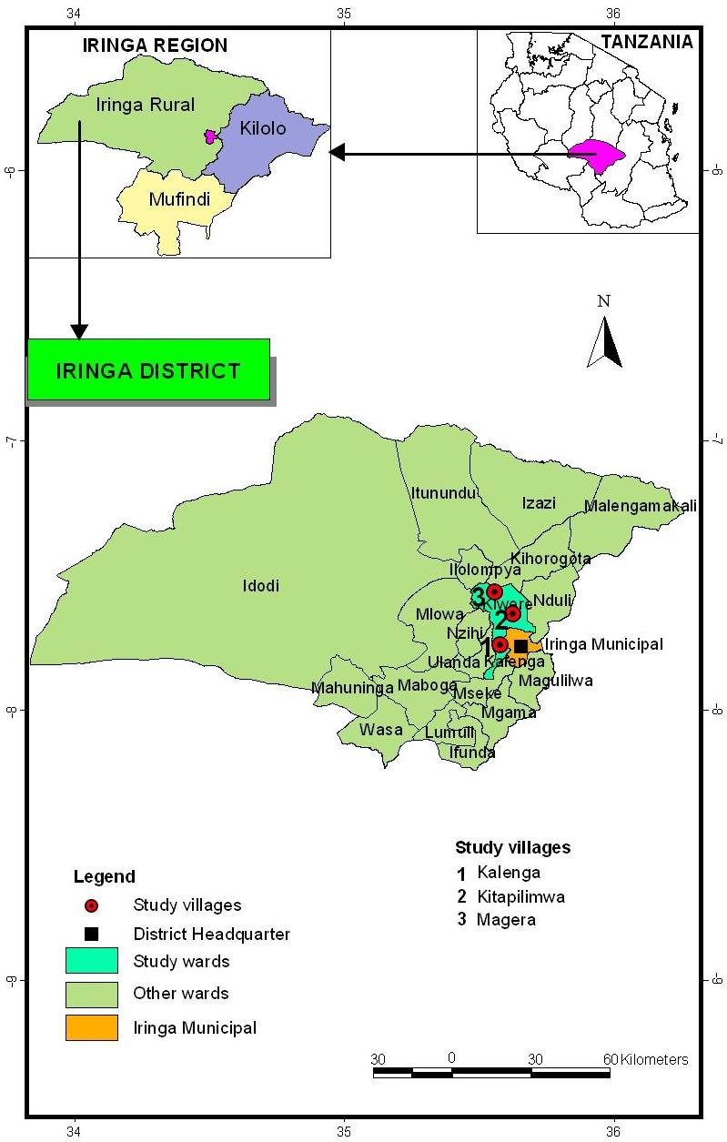
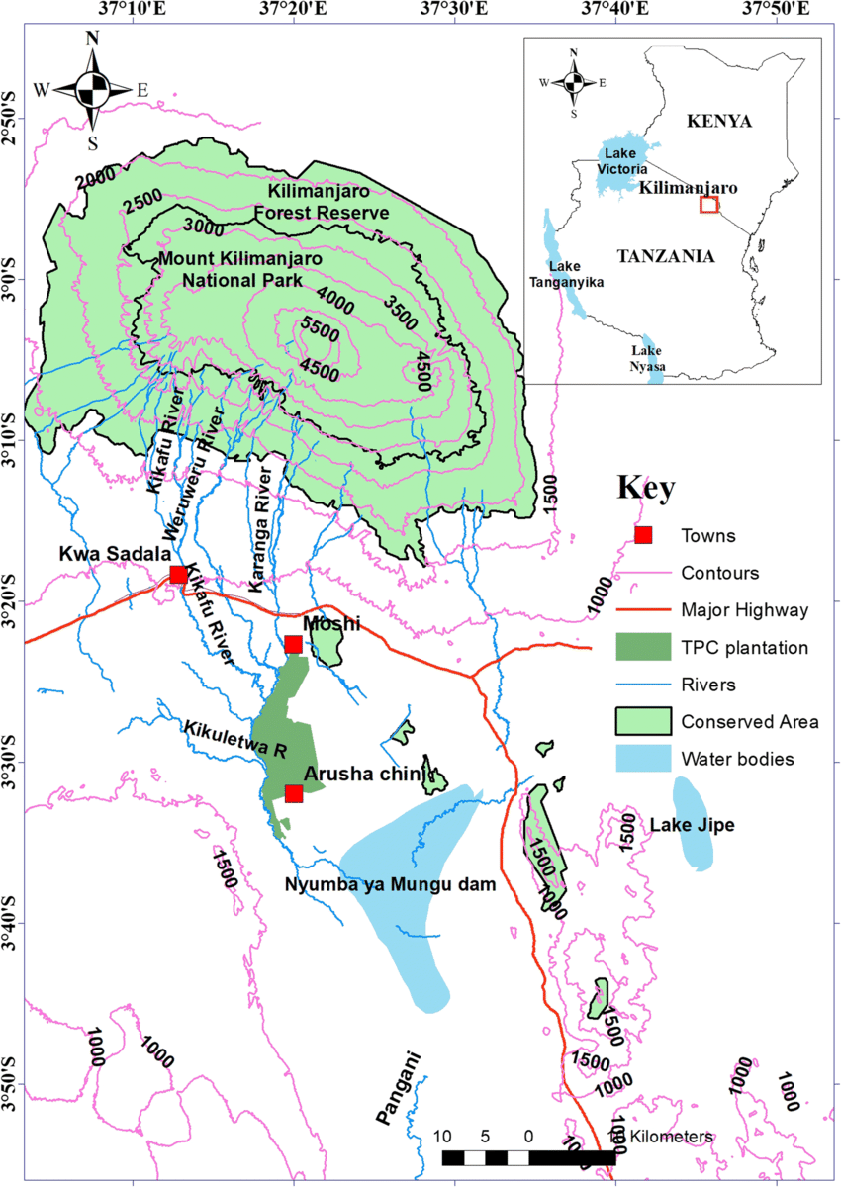
Main Avocado Production Zones:
- Njombe (largest producing region; high quality consistency)
- Iringa
- Kilimanjaro
- Mbeya
- Tanga (emerging highlands)
These highland ecosystems produce dense, flavorful, high-oil Hass fruit.

HARVEST SEASON & AVAILABILITY
Main Harvest Window:
April – September
Peak Export Months:
May – July
Best maturity, strong oil content, optimal firmness.
Availability Calendar:
Month | Availability
April | Early
May | Peak
June | Peak
July | High
August | Moderate
September | Late Crop
October–March | Off Season

QUALITY SPECIFICATIONS & GRADING
CropLink supplies strictly export-grade Hass.
Fruit Specifications:
- Variety: Hass
- Oil Content: 18–22%
- Dry Matter: 23–28% (export standard)
- Skin: Thick, pebbled, darkens upon ripening
- Color: Green while unripe → dark purple/black when ripe

Calibers (Sizes):
- 12, 14, 16, 18, 20, 22, 24
(12–22 are most preferred in EU markets)

Defect Tolerance:
- No anthracnose
- No sunburn spots
- No decay or softening
- Minimal scars only (if allowed by buyer)

Post-Harvest Handling Requirements:
- Harvest at correct maturity
- Immediate pre-cooling
- Cold chain maintained at 5–6°C
- Gentle handling to avoid bruising

CropLink partners only with farms and packhouses that follow proper horticultural standards.

GLOBAL DEMAND & MARKET TRENDS
Top Import Markets for Tanzanian Hass:
- Netherlands (EU entry point)
- France
- Middle East (UAE, Qatar, Saudi Arabia)
- India
- Malaysia
- Singapore
- South Africa
Key Market Trends:
- Growing global consumption of fresh avocados
- Increasing demand for African origins due to seasonal gaps
- EU supermarkets expanding African sourcing programs
- Rising Middle Eastern imports during Ramadan season
- Value chains shifting from Mexico/Peru toward multi-origin sourcing
Tanzanian Hass fits perfectly as a mid-year supplier, between Peru and Kenya seasons.

HOW CROPLINK SUPPORTS BUYERS
Avocado export requires precision, cold-chain discipline, and rapid documentation.
CropLink provides full support across the entire chain:
Our Avocado Services Include:
- Verified sourcing from certified orchards & packhouses
- Maturity testing (dry matter analysis)
- Sorting, washing & grading supervision
- Carton packaging with buyer labeling
- Pre-cooling & cold chain management
- Loading supervision into refrigerated containers
- Temperature control monitoring
- Complete documentation: Phyto, COO, EU standards, Packing List, Invoice, BL
- Real-time reporting (photos, videos, loading confirmations)

We protect buyers from:
- Immature fruit
- Poor cold chain
- Wrong calibers
- Mixed grades
- Packaging errors
- Shipping delays
- Documentation inconsistencies

Your fruit arrives fresh, compliant, and market-ready.

PACKAGING & SHIPMENT OPTIONS
Packaging:
- 4 kg export cartons
- 10 kg export cartons
- Branded cartons (on request)
Container Type:
- 40 ft Reefer Container (standard for fresh produce)
Loading Capacity:
- 40 ft Reefer: 20–22 MT (depending on carton format)
Cold Chain Specs:
- Temperature: 5–6°C
- Ventilation: 20–25%
- Humidity: 85–90%
Shipping Models:
- Direct supermarket programs
- Wholesale distribution
- Multi-container weekly programs

CTA
Want today’s sizes, prices, and availability?
Request Avocado Export Details →

CLOVES

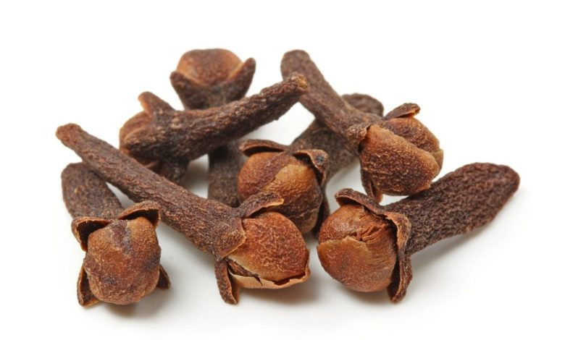
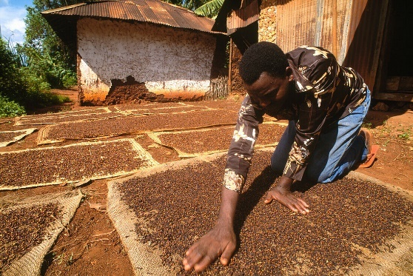
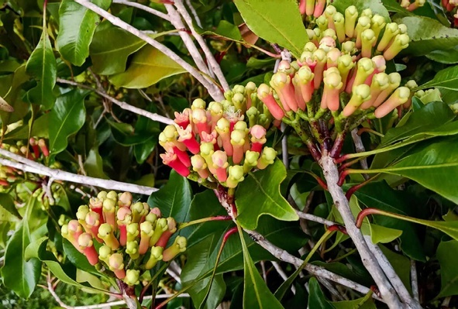

BANNER
Headline:
Premium Tanzanian Cloves with High Oil Content, Strong Aroma, Export-Certified
Subtext:
CropLink supplies high-quality cloves sourced from Zanzibar and Pemba, globally renowned for strong aroma, high eugenol content, and superior flavor profile.
CTA:
Request Clove Prices

ABOUT THE CROP
Tanzania, especially Zanzibar, Pemba, and Tanga coastal belts is globally recognized as one of the world’s leading producers of premium-grade cloves.
Tanzanian cloves are famous for their:
- High essential oil content (15–20%)
- Strong aroma and warm fragrance
- Intense flavor ideal for spice processors
- Deep brown, oily appearance
- Naturally sun-dried, hand-picked quality
- Trusted reputation across Asian and Middle Eastern markets

Cloves from Tanzania are preferred for use in:
- Spice blends
- Essential oil extraction
- Food processing
- Pharmaceuticals
- Cosmetics
- Tea blends
- Perfume and aromatherapy industries

CropLink ensures that buyers access clean, well-dried, oil-rich cloves handled under strict quality and export standards.

WHY TANZANIA’S CLOVES ARE SUPERIOR
✔ Exceptionally High Oil Content
Tanzanian cloves contain 15–20% eugenol, one of the highest levels globally.
✔ Complex, Warm, Long-Lasting Aroma
Highly valued in India, UAE, Saudi Arabia, and Europe.
✔ Clean Sun Drying
Coastal drying conditions produce dry, aromatic, long-lasting incense-like flavor.
✔ Strong Natural Color
Deep brown / reddish appearance indicates maturity & quality.
✔ Minimal Chemical Use
Most clove farming in Zanzibar is organic by default.
✔ Consistent Quality
Due to long-standing farming traditions and ideal tropical agro-climatic conditions.

MAJOR GROWING REGIONS & MAPS
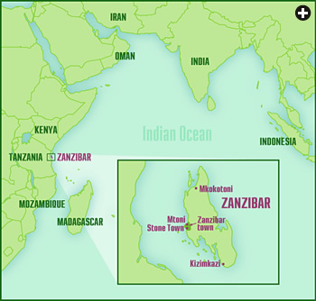

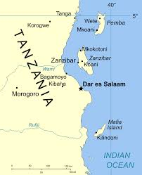
Primary Clove-Producing Zones:
- Zanzibar (Unguja) — premium grade; highest volumes
- Pemba Island — historically produces some of the most aromatic cloves
- Tanga Coastline — moderate levels but excellent quality
- Kilimanjaro (small pockets) — limited production but clean quality

Zanzibar & Pemba remain the gold standard of clove origins.

HARVEST SEASON & AVAILABILITY
Main Harvest Season (Zanzibar & Pemba):
September – January
Peak Buying Window:
October – December
Best drying conditions + strongest aroma retention.
Availability Calendar:
Month | Availability
September | Early Harvest
October | High
November | Very High
December | Peak Quality
January | Moderate
February–August | Off Season

QUALITY SPECIFICATIONS & GRADING
CropLink supplies cloves aligned with buyer, spice processor, and essential oil industry standards.
Standard Export Specs:
- Handpicked Quality
- Foreign Matter: ≤ 1%
- Stems: ≤ 5% (depending on grade)
- Moisture: ≤ 12%
- Whole Flower Cloves: 95%+
- Color: Reddish-brown / deep brown
- Eugenol (oil content): 15–20%
- Odor: Strong, warm, natural clove aroma
Grades Available:
- Whole Cloves – Grade A (Premium)
- Whole Cloves – Grade B
- Clove Stems (for essential oil extraction)
We provide samples, detailed photos, and moisture/oil content updates before purchase.

GLOBAL DEMAND & MARKET TRENDS
Major Importers:
- India
- Pakistan
- Saudi Arabia
- UAE
- Egypt
- Indonesia
- Sri Lanka
- Europe (Netherlands, Germany, France)

Demand Drivers:
- Growing spice blending industry
- High demand for natural essential oils
- Increase in herbal teas and medicinal preparations
- Expanding cosmetic and aromatherapy industries

Tanzanian cloves remain among the top three most demanded origins, alongside Indonesia and Madagascar.

HOW CROPLINK SUPPORTS BUYERS (OUR POSITION)
Cloves require strict quality oversight, especially regarding aroma strength, dryness, and cleanliness.
CropLink ensures:
Professional Sourcing
- Verified harvesting cooperatives
- Proper sun drying & hygiene checks
- Aroma intensity verification
Strict Quality Control
- Moisture testing
- Sorting & cleaning checks
- Oil content guidance (where applicable)
Reliable Export Coordination
- Bagging supervision
- Weighing & warehouse handling
- Loading inspection (photos, videos, seals)
Complete Documentation
- Phytosanitary certificate
- Certificate of Origin
- Fumigation certificate
- Inspection reports
- Packing list & invoice
We protect buyers from:
- Wet or immature cloves
- Stale aroma
- Excess stems / FM
- Mold contamination
- Poor warehouse storage
- Dishonest mixing of grades
You receive cloves that are clean, aromatic, mature, and professionally handled.

PACKAGING & SHIPMENT OPTIONS
Packaging:
- 50 kg PP bags (standard)
- 25 kg bags (premium spice processors)
- Bulk bags for essential oil manufacturers
Container Capacities:
- 20 ft container: 16–18 MT
- 40 ft container: 24–25 MT
Loading Options:
- Single-container
- Multi-container seasonal sourcing
- Mixed spices container (cloves + black pepper + cinnamon)

CTA
Need today’s prices, samples, or oil content details?
Request Clove Prices →

COFFEE (ARABICA & ROBUSTA)

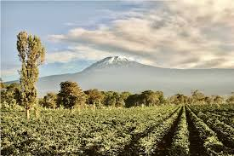
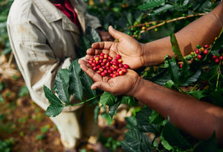

BANNER
Headline:
Specialty-Grade Tanzanian Coffee, Premium Arabica & Bold Robusta
Subtext:
CropLink supplies high-quality Arabica from Tanzania’s highlands and strong-bodied Robusta from the Kagera basin professionally processed, graded, and export-certified.
CTA:
Request Coffee Export Specifications

ABOUT COFFEE
Tanzania is one of Africa’s most respected coffee origins known for floral, aromatic Arabica from high-altitude regions and rich, chocolatey Robusta from Lake Zone districts.
Tanzanian coffee is globally appreciated because of:
- High-altitude Arabica (1,200–2,000m)
- Naturally rich volcanic soils
- Hand-picked harvest
- Washed & natural processing
- Balanced acidity and sweetness
- Strong aroma profiles
- Consistent bean size and density

CropLink works with certified coffee producers, AMCOS, estates, and washing stations to deliver fully traceable, export-ready green coffee beans.

WHY TANZANIA’S COFFEE IS SUPERIOR
✔ High-Altitude Growing Conditions
Cool highlands in Kilimanjaro, Mbeya & Songwe produce dense, flavorful Arabica beans.
✔ Unique Flavor Notes
Citrus, berry, chocolate, floral, winey, or nutty undertones depending on region.
✔ Hand-Picked Harvest
Selective picking ensures clean, ripe cherries.
✔ Multiple Processing Methods
- Fully Washed
- Natural / Sun-Dried
- Honey Processed
✔ Traceability Through AMCOS
Group-based production ensures consistent volume and quality management.
✔ Strong Global Reputation
Tanzanian coffee regularly appears in premium blends and specialty roaster menus.

COFFEE GROWING REGIONS & MAPS
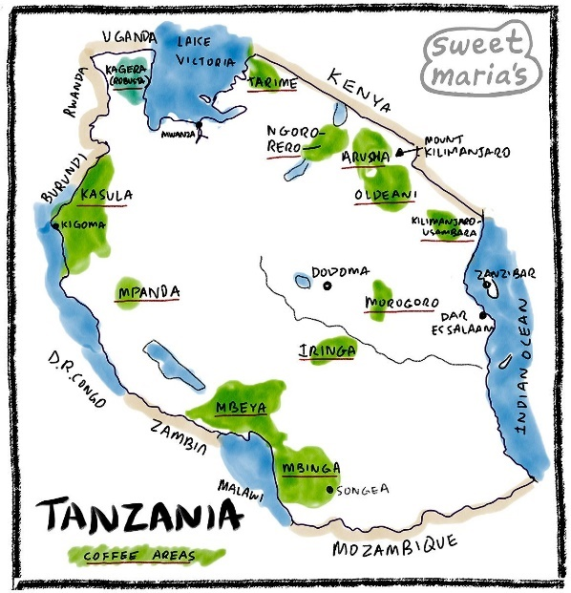

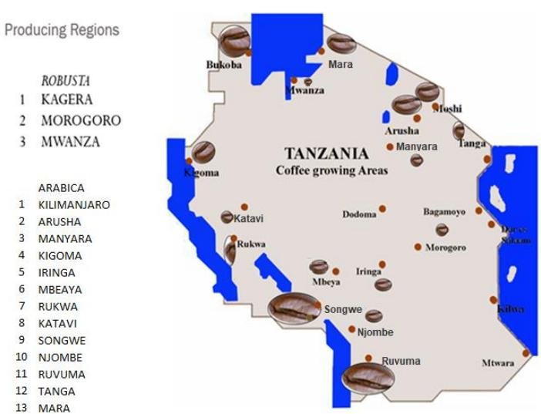

Arabica Coffee Regions (High Altitude, Specialty Grade)
- Kilimanjaro — floral, bright acidity, medium body
- Mbeya — balanced, chocolatey, consistent quality
- Songwe — sweet, winey profiles
- Arusha — aromatic, medium acidity
- Iringa & Njombe — emerging specialty zones
Robusta Coffee Regions (Low Altitude, Strong Body)
- Kagera — bold, chocolate-like, full-bodied
- Bukoba — traditional East African Robusta profile
Arabica accounts for ~70% of Tanzania’s coffee exports, Robusta ~30%.

HARVEST SEASON & AVAILABILITY
Arabica Harvest:
- July – December
- Peak: August – October
Robusta Harvest:
- April – July
Availability Calendar (Green Coffee):
Month | Arabica | Robusta
January | Available | Off-season
February | Available | Off-season
March | Available | Early
April | Available | High
May | Available | High
June | Early | Very High
July | High | Very High
August | Very High | Moderate
September | Very High | Moderate
October | Peak | Low
November | High | Low
December | High | Off-season

QUALITY SPECIFICATIONS & GRADING
Arabica Specifications (Green Beans)
- Moisture: 10–12%
- Screen Size: 15, 16, 17, 18
- Defects: < 8/300g (depending on buyer grade)
- Flavor Profile: floral, citrus, berry, chocolate, winey
- Processing: washed / natural
- Origin: Kilimanjaro, Arusha, Mbeya, Songwe
Robusta Specifications (Green Beans)
- Moisture: 10–12%
- Screen Size: 15–17
- Defects: < 10/300g
- Flavor Profile: bold, earthy, chocolate
- Use: espresso blends, instant coffee, roasting
Grades Available:
- AAA (Top Grade Arabica)
- AA
- A
- PB (Peaberry)
- FAQ (Fair Average Quality) for Robusta
Export Requirements:
- Clean, defect-controlled beans
- Proper drying to export moisture level
- Bagging in clean jute sacks
- Fumigation (if required by buyer)

GLOBAL DEMAND & MARKET TRENDS
Major Importers of Tanzanian Coffee:
- Germany
- Japan
- Italy
- USA
- South Korea
- Middle East (Saudi Arabia, UAE, Qatar)
- India (select roasters)
Market Trends:
- Growing specialty coffee consumption worldwide
- Increased demand for traceable, ethical origins
- Rising demand for African Arabica in premium blends
- Strong market for Robusta due to global instant coffee boom
- Tanzania’s mid-year harvest fills global supply gaps between Kenya & Ethiopia cycles
Tanzanian coffee continues to gain attention in the specialty market.

HOW CROPLINK SUPPORTS BUYERS
Coffee export requires exact documentation, controlled humidity, clean processing, and traceability.
CropLink ensures:
✔ Verified sourcing
From certified farms, estates, AMCOS, and washing stations.
✔ Quality assurance
- Screen sizing
- Defect checking
- Moisture meter readings
- Cup profile evaluation (where required)
✔ Proper handling & storage
- Clean jute bags
- Controlled warehouse storage
- Protection from humidity
✔ Controlled transportation
Preventing mold, moisture uptake, and bean defects.
✔ Complete documentation:
- ICO certificate (where required)
- Phytosanitary
- Certificate of Origin
- Fumigation
- Packing List
- Invoice
- BL instructions
✔ Transparent communication
Real-time updates, photos, videos, and cupping results (if requested).
We eliminate risks like:
- Mold
- High defects
- Moisture absorption
- Inconsistent grades
- Poor processing
- Wrong screen sizes
You get coffee that is clean, traceable, consistent, and export-certified.

PACKAGING & SHIPMENT OPTIONS
Packaging:
- 60 kg Jute Bags (standard)
- 30 kg (on special request)
- GrainPro liners available (premium shipments)
Container Loading:
- 20 ft container: 19–20 MT
- 40 ft container: 27–29 MT
Shipment Models:
- Single-origin containers
- Mixed Arabica calibers
- Arabica + Robusta combinations
- Custom blends for roasters

CTA
Need screen sizes, cupping profiles, or today’s prices?
Request Coffee Export Specifications →

COCOA (FERMENTED DRIED BEANS)

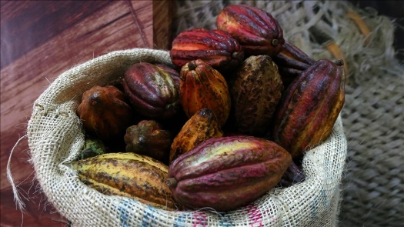
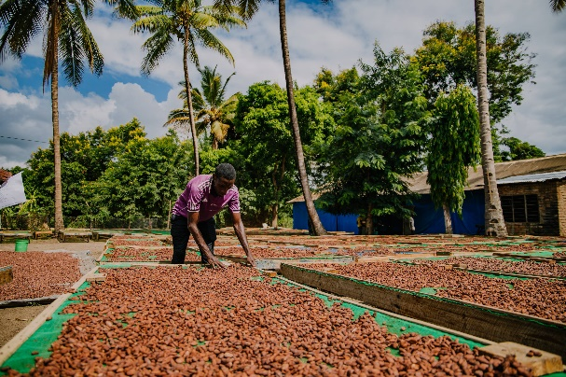
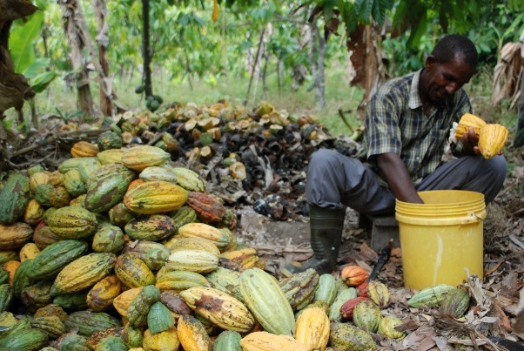

BANNER
Headline:
Premium Tanzanian Cocoa, Rich Flavor, Clean Fermentation, Export-Certified
Subtext:
CropLink supplies high-quality fermented and dried cocoa beans sourced mainly from Kyela known for clean flavor, strong aroma, and consistent fermentation practices suitable for chocolate makers and processors.
CTA:
Request Cocoa Supply Options

ABOUT COCOA
Tanzania is home to one of East Africa’s most promising cocoa origins especially from Kyela district (Mbeya region), where fertile volcanic soils and tropical rain patterns create cocoa with:
- Rich chocolate notes
- Strong cocoa aroma
- Low bitterness
- Clean fermentation
- High butter content
- Consistent bean size
Tanzanian cocoa is increasingly used in:
- Craft chocolate
- Premium dark chocolate
- Cocoa powder and butter extraction
- Beverage blends
- Confectionery products
CropLink supplies clean, well-fermented beans handled through professional post-harvest systems to meet international quality expectations.

WHY TANZANIA’S COCOA IS SUPERIOR
✔ Unique Flavor Profile
Known for bright acidity, fruity undertones, and strong cocoa depth.
✔ Clean Fermentation Practices
3–7 day fermentation under controlled conditions improves flavor and reduces bitterness.
✔ Strong Aroma Retention
Sun-dried beans maintain strong cocoa fragrance.
✔ Natural, Low-Chemical Farming
Smallholder farmers use organic-leaning methods.
✔ Consistent Bean Size
Ideal for chocolate makers seeking uniform roasting results.
✔ Volcanic Soil & Tropical Climate
Kyela’s natural environment produces premium cocoa characteristics.

GROWING REGIONS & MAPS
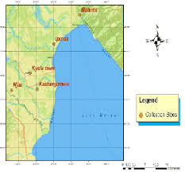
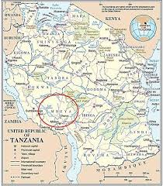
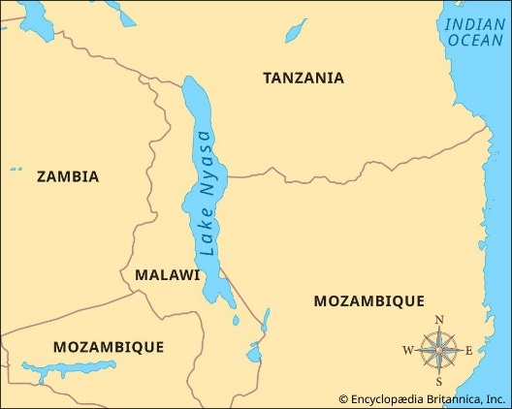
Primary Cocoa-Producing Regions:
- Kyela (Mbeya Region) — main production hub; premium flavor
- Rungwe — secondary high-quality zone
- Mbozi — emerging production pockets
- Kigoma — small quantum, improving quality
Kyela remains the flagship zone due to strong farmer experience and ideal climate.
HARVEST SEASON & AVAILABILITY
Main Cocoa Crop:
May – October
Peak Quality Season:
June – August
Availability Calendar:
Month | Availability
May | Early
June | High
July | Very High
August | Peak
September | High
October | Moderate
November–April | Off Season

QUALITY SPECIFICATIONS & GRADING
CropLink supplies export-standard fermented & dried cocoa beans.
Standard Cocoa Specs:
- Fermentation: 80–90%
- Moisture: ≤ 7.5%
- Mold: < 3%
- Slaty Beans: < 3%
- Broken Beans: < 2%
- Foreign Matter: < 1%
- Bean Count: 90–110 beans/100 g (varies by region)
- Flavor Notes: fruity, cocoa-rich, mild acidity
Grades Available:
- Grade 1 (Premium)
- Grade 2
- FAQ (Fair Average Quality)
Accepted Processing Methods:
- Fermented (3–7 days)
- Sun-dried
Bean quality is verified through cut tests, moisture checks, and fermentation scoring.

GLOBAL DEMAND & MARKET TRENDS
Top Buyers of Tanzanian Cocoa:
- Europe (Netherlands, Germany, France, Belgium)
- USA
- Japan
- Malaysia
- Singapore
- Middle Eastern chocolate manufacturers

Trending Market Drivers:
- Rapid growth in craft chocolate
- Demand for traceable, ethical supply chains
- Rising preference for African premium cocoa origins
- Global shortage of cocoa pushing processors to expand sourcing
- Sustainable farming increasing market value

Tanzania’s cocoa fits perfectly into the premium, small-origin, specialty chocolate segment.

HOW CROPLINK SUPPORTS BUYERS
Cocoa export requires strict post-harvest control, especially around fermentation, moisture, and mold prevention.
CropLink ensures full compliance and traceability.
Our Support Includes:
✔ Professional Sourcing
- Verified farmer groups in Kyela & Rungwe
- Field checks for fermentation practices
✔ Quality Assurance
- Moisture meter testing
- Cut test for fermentation levels
- Mold and slate inspection
- Size and uniformity checks
✔ Proper Handling & Storage
- Sun drying supervision
- Hygienic warehouse handling
- Proper bagging & fumigation
✔ Documentation & Export Coordination
- Phytosanitary certificate
- Certificate of Origin
- Fumigation certificate
- Inspection reports
- Invoice & Packing List
- BL instructions
- Export clearance support
We protect buyers from:
- Wet beans
- Mold contamination
- Poor fermentation
- Low butter content
- Inconsistent bean sizes
- Improper storage
- Deadline delays
You receive clean, well-fermented, export-certified cocoa beans suitable for specialty and industrial markets.

PACKAGING & SHIPMENT OPTIONS
Packaging:
- 50 kg jute bags (standard)
- 25 kg bags (premium buyers)
- GrainPro liners available (on request)
Container Capacity:
- 20 ft container: 16–18 MT
- 40 ft container: 24–25 MT
Shipment Models:
- Single-origin containers
- Multi-container sourcing programs
- Seasonal supply contracts

CTA
Need current bean counts, fermentation levels, or sample cut tests?
Request Cocoa Supply Options →

BLACK PEPPER

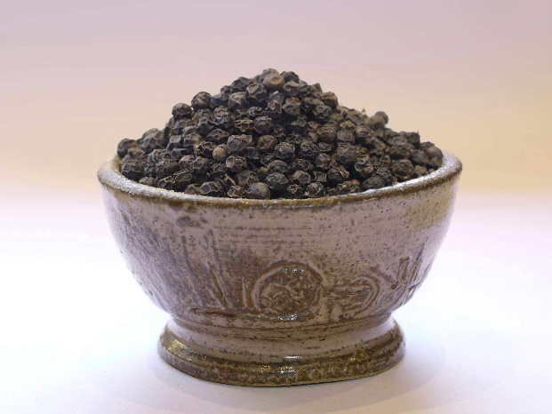
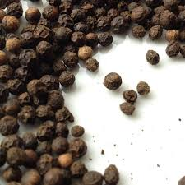

BANNER
Headline:
Aromatic Tanzanian Black Pepper that is Bold Flavor, High Pungency, Export-Certified
Subtext:
CropLink supplies premium sun-dried black pepper sourced from Tanzania’s spice-growing regions known for strong aroma, high volatile oil content, and clean post-harvest handling.
CTA:
Request Black Pepper Offer

ABOUT BLACK PEPPER
Tanzania produces distinctive black pepper that competes strongly with Indian, Vietnamese, and Indonesian origins.
Grown in Morogoro, Tanga, and Zanzibar, Tanzanian pepper is appreciated for:
- Sharp pungency
- Warm, spicy aroma
- Naturally sun-dried production
- High volatile oil content (2–4%)
- Clean grains with uniform color
- Minimal chemical use
This pepper is ideal for:
- Spice processors
- Pepper mills
- Food manufacturers
- Blending and seasoning companies
- Export-oriented spice traders
CropLink ensures that every shipment meets international hygiene, aroma, and dryness requirements.

WHY TANZANIA’S BLACK PEPPER IS SUPERIOR
✔ Strong Aroma & Pungency
Due to tropical coastal climate and fertile soils.
✔ High Volatile Oil Content (2–4%)
A key metric for flavor strength.
✔ Naturally Sun-Dried
Enhanced aroma retention and clean moisture profile.
✔ Low Chemical Exposure
Ideal for markets demanding natural spices.
✔ Uniform Grain Structure
Preferred by spice mills and industrial processors.
✔ Competitive Pricing
Versus Vietnam and India for similar quality classes.

MAJOR GROWING REGIONS & MAPS
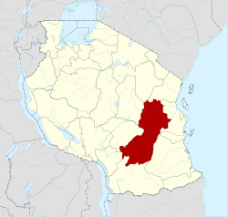
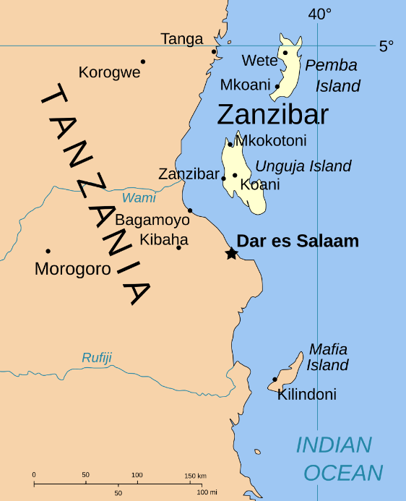
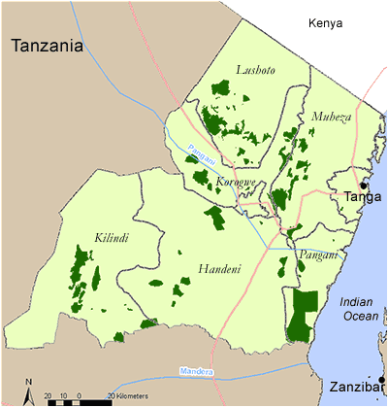

Primary Black Pepper Zones in Tanzania:
- Morogoro — largest and most consistent production
- Tanga — coastal climate creates strong aroma
- Zanzibar — small volume but premium quality
- Pwani Region — emerging producer

These regions have ideal humidity and shade-grown forest systems that produce high-oil pepper berries.
HARVEST SEASON & AVAILABILITY
Main Harvest Season:
July – October
Peak Buying Season:
August – October
Beans are fully mature and properly sun-dried.
Availability Calendar:
Month | Availability
July | Early
August | High
September | Very High
October | Peak
November | Moderate
December–June | Off Season

QUALITY SPECIFICATIONS & GRADING
CropLink supplies black pepper aligned with global spice processing standards.
Standard Specs:
- Moisture: ≤ 12%
- Volatile Oil Content: 2–4% (strong aroma indicator)
- Black Pepper Density: 500–550 g/L (Grade A)
- Foreign Matter: ≤ 1%
- Light Berries: ≤ 2%
- Mold/Insect Damage: < 1%
Grades Available:
- FAQ (Fair Average Quality)
- 500 G/L Premium Grade
- 550 G/L High Density Grade
Color:
Deep black / dark brown uniformity.
Accepted Processing Methods:
- Sun drying (preferred)
- Mechanical drying (on request)
Pepper is cleaned, sorted, and bagged under strict hygiene conditions.

GLOBAL DEMAND & MARKET TRENDS
Major Buyers:
- India
- UAE
- Saudi Arabia
- Egypt
- Pakistan
- Sri Lanka
- Europe (select buyers)
Demand Drivers:
- Growth of spice trade in Middle East & Asia
- Increased global consumption of natural seasonings
- Preference for clean, sun-dried, chemical-light origins
- Growing global spice blend industry
Tanzanian pepper is gaining recognition due to its strong aroma and clean drying process.

HOW CROPLINK SUPPORTS BUYERS
Black pepper export requires strict aroma control, moisture management, and cleanliness.
CropLink ensures:
✔ Verified Sourcing
From spice farmers and AMCOS in Morogoro, Tanga & Zanzibar.
✔ Quality Testing
- Moisture checks
- Volatile oil content verification
- Grain density
- FM & mold checks
✔ Clean Post-Harvest Handling
- Controlled drying
- Proper storage
- Hygienic bagging
✔ Professional Loading Supervision
- Pre-shipment inspection
- Bagging checks
- Palletization (for premium buyers)
- Container fumigation
- Seal number verification
✔ Document Accuracy
- Phytosanitary
- Certificate of Origin
- Fumigation Certificate
- Packing List & Invoice
- BL instructions
- Inspection reports
We eliminate risks like:
- High moisture
- Mold contamination
- Weak aroma
- Mixed grades
- Insects
- Poor drying
You receive clean, aromatic, high-oil-content black pepper ready for the global spice market.

PACKAGING & SHIPMENT OPTIONS
Packaging:
- 25 kg bags (premium)
- 50 kg PP bags
- Vacuum-packed options (for specialty buyers)
Container Loading:
- 20 ft container: 17–18 MT
- 40 ft container: 25–26 MT
Shipping Models:
- Pepper-only shipments
- Mixed spice shipments (pepper + cloves + cinnamon + cardamom)

CTA
Need today’s aroma specs, oil content, or pricing?
Request Black Pepper Offer →

CARDAMOM & CINNAMON

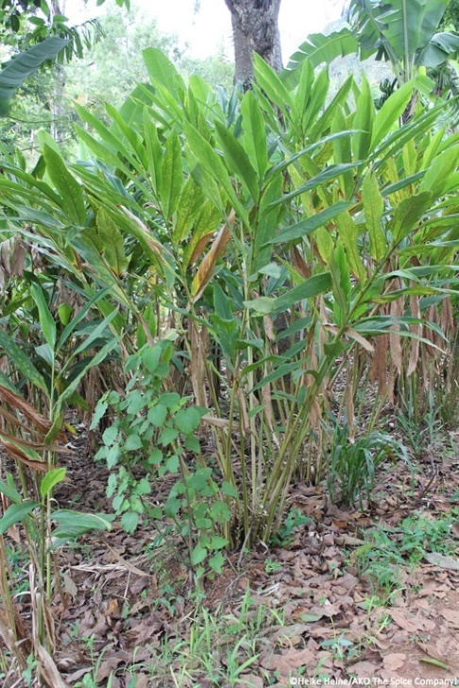

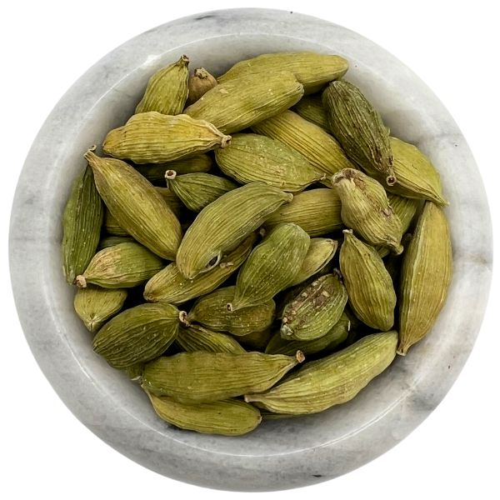

CARDAMOM (ELAICHI) — PREMIUM EAST AFRICAN SPICE
BANNER
Headline:
Aromatic Tanzanian Cardamom that is Fresh, Green, and Export-Certified
Subtext:
CropLink supplies premium green cardamom grown in Tanzania’s high-altitude zones — known for bold aroma, natural green color, and high volatile oil content demanded by specialty spice buyers.
CTA:
Request Cardamom Offer

ABOUT CARDAMOM
Tanzania produces small but premium-quality cardamom in its highlands and tropical forest areas. Known for vibrant green pods, strong fragrance, and warm, sweet flavor, Tanzanian cardamom is suitable for:
- Spice blends
- Tea and chai masala
- Middle Eastern sweets
- Bakery flavoring
- Essential oil extraction
- Premium retail packaging
It stands out due to natural color retention and low chemical exposure.

WHY TANZANIA’S CARDAMOM IS SUPERIOR
✔ Strong, long-lasting aroma
High volatile oil content gives rich fragrance.
✔ Natural green color
Shade drying preserves original pod color, boosting market value.
✔ Ideal growing conditions
Humid, high-altitude microclimates produce aromatic, bold pods.
✔ Minimal chemical use
Ideal for buyers seeking clean and natural spices.
✔ Uniform pod size
Suitable for premium supermarket packaging.

GROWING REGIONS
- Tanga (Usambara Mountains) — main production zone
- Morogoro — deep green pods, warm aroma
- Kilimanjaro — small volume but premium quality
- Zanzibar — pockets of forest-grown crop
The Usambara Mountains produce Tanzania’s most aromatic and visually appealing cardamom.

HARVEST SEASON & AVAILABILITY
- Main Season: July – December
- Peak Season: August – October

Month | Availability
July | Early
August | High
September | Peak
October | High
November | Moderate
December | Late
January–June | Off Season

QUALITY SPECIFICATIONS
Standard Export Specs:
- Color: Deep green
- Pod Size: 6–8 mm
- Moisture: ≤ 12%
- Foreign Matter: < 1%
- Aroma: Sweet, warm, strong
- Volatile Oil Content: 3–5%
- Uniformity: 95%

Grades Available:
- Super Green (Premium)
- Bold Green (Grade A)
- Mixed Green (Grade B)

GLOBAL DEMAND & MARKET TRENDS
Key Import Markets
- Middle East (UAE, Saudi Arabia, Qatar)
- India
- Pakistan
- Iran
- Europe (select buyers)
Trends
- Rising tea/flavored beverage industry
- Increased natural spice consumption
- Growth in premium retail spice packaging

Tanzanian cardamom fits especially well in Arabic, South Asian, and African specialty markets.

HOW CROPLINK SUPPORTS BUYERS
We manage all sensitive aspects:
✔ Sourcing from verified growers
✔ Color preservation via shade-drying
✔ Moisture control
✔ Sorting & grading supervision
✔ Packaging oversight
✔ Fumigation & documentation
✔ Loading inspection (photos/videos)
We protect you from:
- Pale color
- Poor aroma
- High moisture
- Mold
- Broken pods
- Mixed grades

PACKAGING & SHIPMENT OPTIONS
Packaging
- 5 kg & 10 kg cartons for premium grades
- 25 kg bags
- 50 kg PP bags (standard)
Shipment
20 ft container: 13–15 MT
40 ft container: 25–26 MT

CTA
Need today’s grades, color photos, or price levels?
Request Cardamom Offer →

2. CINNAMON — SWEET, AROMATIC TANZANIAN CINNAMON BARK
BANNER
Headline:
Premium Tanzanian Cinnamon that is Sweet Aroma, Clean Bark, High Oil Content
Subtext:
CropLink supplies naturally grown cinnamon sourced mainly from Tanzania’s spice islands and coastal regions known for its warm aroma, sweet undertones, and clean bark structure.
CTA:
Request Cinnamon Prices

ABOUT CINNAMON
Tanzania has long been recognized for producing high-quality Cinnamomum verum (true cinnamon) and cassia-type cinnamon in various pockets.
It is used globally for:
- Spice blends
- Bakery, confectionery
- Beverage infusion
- Essential oil extract
- Cosmetic & aromatherapy industries

Tanzanian cinnamon is valued for its sweet aroma, smooth quills, and clean bark free from dust and mold.

WHY TANZANIA’S CINNAMON IS SUPERIOR
✔ Sweet, warm flavor
Ideal for bakery, tea blends, and spice mixes.
✔ Strong, consistent aroma
High cinnamaldehyde content.
✔ Naturally grown
Most farms use organic-leaning traditional methods.
✔ Clean bark structure
Good for quilling and premium retail packaging.
✔ Naturally sun-dried
Improves fragrance and color retention.

GROWING REGIONS
- Zanzibar — historically strong spice producer
- Pemba Island
- Tanga Coastal Belt
- Morogoro (forest pockets)
Zanzibar cinnamon is particularly valued for its natural aroma and sweetness.

HARVEST SEASON & AVAILABILITY
- Main Harvest: June – October
- Secondary Harvest: January – February

Month | Availability
June | High
July | Very High
August | Peak
September | High
October | Moderate
January–February | Moderate
March–May | Off-season

QUALITY SPECIFICATIONS
Standard Specs:
- Moisture: ≤ 12%
- Quill Length: 8–22 cm (or custom)
- Thickness: Uniform
- Foreign Matter: < 1%
- Color: Golden brown to dark brown
- Aroma: Warm, sweet, strong
- Oil Content: 1–2% (varies by region)

Grades Offered:
- Cinnamon Quills (Premium)
- Cinnamon Cut Pieces
- Cinnamon Chips
- Cinnamon Powder (on request)

GLOBAL DEMAND & MARKET TRENDS
Top Markets
- India
- UAE
- Saudi Arabia
- Egypt
- Europe
- USA
- South Africa
Trends
- Expanding use in tea blends
- Growth in bakery & confectionery industries
- Rising essential oil market
- Increased demand for true (Ceylon-type) cinnamon origins

Tanzanian cinnamon is increasingly recognized as a clean, natural, sun-dried origin.

HOW CROPLINK SUPPORTS BUYERS
✔ Strict sourcing
Trusted producers in Zanzibar, Pemba, and Tanga.
✔ Quality assurance
- Moisture testing
- Color & aroma checks
- Bark cleanliness
- Thickness consistency
✔ Good packaging standards
- Clean bags
- Mold prevention
- Proper drying and storage
✔ Full export coordination
Phytosanitary, COO, fumigation, inspection reports, loading logs, seal verification, BL management.
Risks we eliminate:
- Mold
- Dust contamination
- Low aroma levels
- Mixed grades
- Bark discoloration

PACKAGING & SHIPMENT OPTIONS
Packaging Options
- 20 kg bags
- 25 kg bags
- 50 kg bags
- Carton packaging for quills (premium buyers)

Shipment Options
- 20 ft container: 10–12 MT
- 40 ft container: 20–22 MT

CTA
Need samples, aroma specs, or today’s export prices?
Request Cinnamon Prices →

BEANS (RED, YELLOW, BLACK & SOYA)

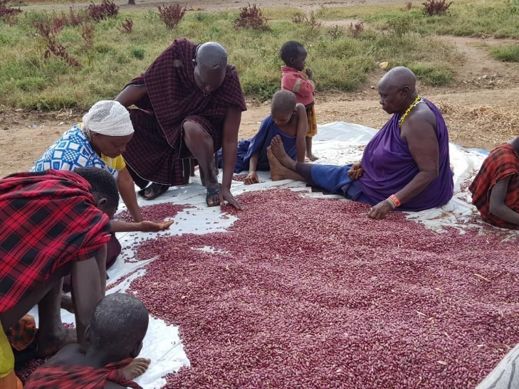
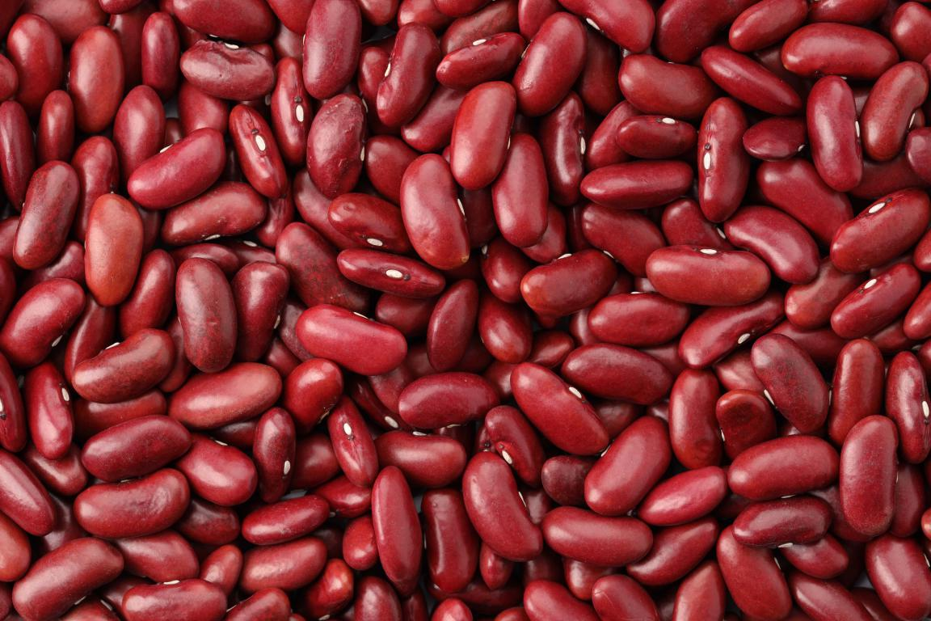
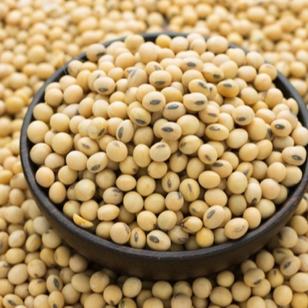

BANNER
Headline:
High-Quality Tanzanian Beans. Clean, Naturally Dried, Export-Grade
Subtext:
CropLink supplies premium dry beans sourced from Tanzania’s leading farming belts — professionally cleaned, graded, and handled to meet strict global export standards.
CTA:
Request Beans Prices & Specs

ABOUT THE TANZANIA’S BEANS
Tanzania is one of East & Southern Africa’s most reliable origins for high-quality, naturally dried edible beans.
Our bean varieties are grown across fertile regions in Mbeya, Songwe, Ruvuma, Manyara, Dodoma, Kigoma, Kagera, and are known for:
- Uniform grain size
- Clean sorting
- Low moisture
- Good cooking qualities
- Natural sun drying
- Consistent supply volumes

CropLink works directly with farmers, AMCOS, and commercial growers to supply export-ready beans compliant with food safety and market requirements.

WHY TANZANIA’S BEANS ARE SUPERIOR
✔ Naturally Sun-Dried
Enhances storage quality and reduces mold risk.
✔ Low Chemical Exposure
Smallholder farmers use minimal synthetic inputs.
✔ Clean, Well-Sorted Grains
Suitable for food processors and wholesalers.
✔ Strong Seasonal Volumes
Reliable supply from several agro-ecological zones.
✔ Competitive Prices
Makes Tanzania a preferred alternative to Ethiopia and Zambia.
✔ Excellent Cooking Quality
Soft texture, uniform grains, stable color.

GROWING REGIONS

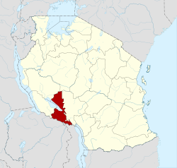
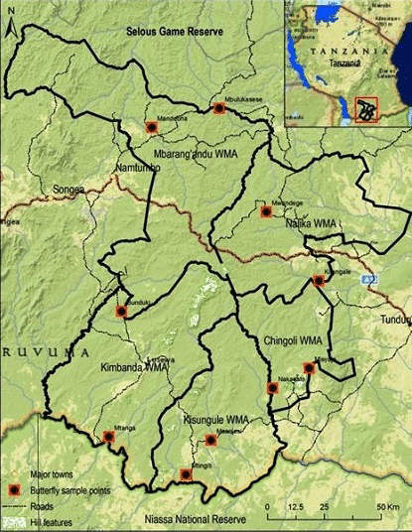

Major Bean-Producing Zones:
- Mbeya — high-quality kidney & yellow beans
- Songwe — consistent volumes, low moisture
- Ruvuma — premium red kidney and yellow
- Manyara — black beans & mixed varieties
- Kigoma / Kagera — strong on soybeans
- Dodoma / Singida — drought-resilient varieties

HARVEST SEASON & AVAILABILITY
Main Season:
May – September
Peak Season:
June – August

Availability Calendar:
Month | Availability
May | Early
June | High
July | Very High
August | Peak
September | High
October | Moderate
November–April | Off Season

QUALITY SPECIFICATIONS (All Beans)
General Export Specs:
- Moisture: ≤ 13%
- Purity: ≥ 98%
- Foreign Matter: ≤ 2%
- Broken Grains: ≤ 3%
- Weevils/Mold: 0%
- Color Uniformity: ≥ 95%
Packaging:
- 25 kg or 50 kg PP bags
- Custom printing available
- Bulk packaging on request

VARIETIES SUPPLIED BY CROPLINK
Below is the combined detail for each type.

A. RED KIDNEY BEANS (RKB)

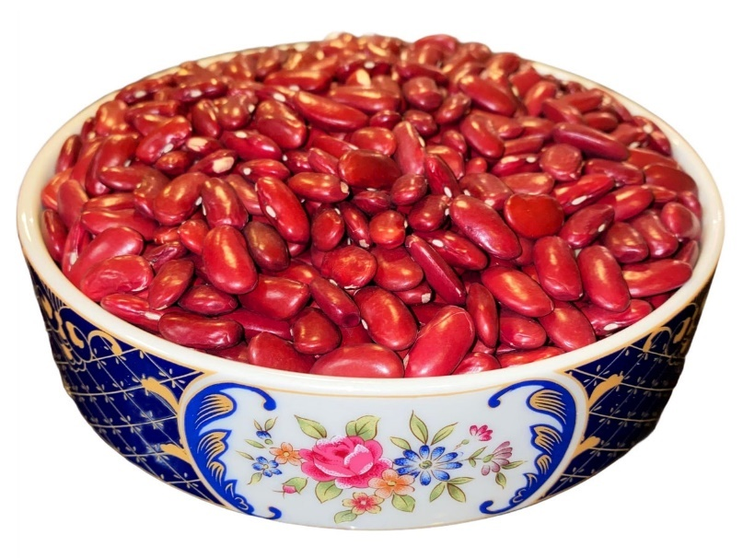
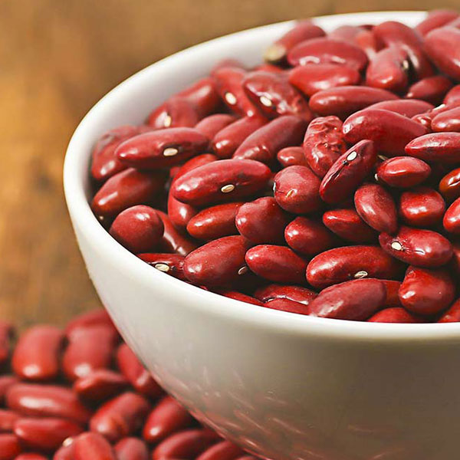
Overview
Tanzanian RKBs are known for their deep red color, strong grain structure, and excellent cooking quality. High demand in India, Pakistan, UAE, Mauritius, and Europe.
Specifications:
- Moisture: ≤ 13%
- Purity: 98–99%
- FM: ≤ 1–2%
- Size: 180–220 grains/100g
- Color: Deep red, uniform
Uses:
- Consumer retail
- Canned food processors
- Bulk food distribution

B. YELLOW BEANS
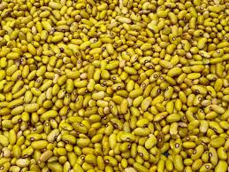
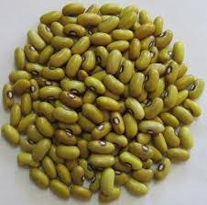
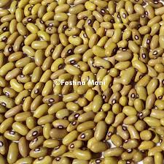
Overview
Extremely popular for their golden-yellow color, soft cooking texture, and strong demand in East Africa, Middle East, and Indian Ocean islands.
Specifications:
- Purity: ≥ 98%
- Moisture: ≤ 13%
- Uniformity: ≥ 95%
- Damage: ≤ 3%
Key Markets:
- India (select processors)
- UAE
- DRC
- Rwanda
- Burundi
- Indian Ocean islands (Mauritius, Seychelles)

C. BLACK BEANS
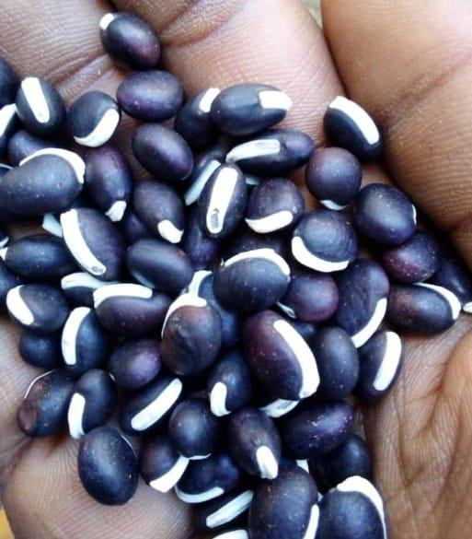
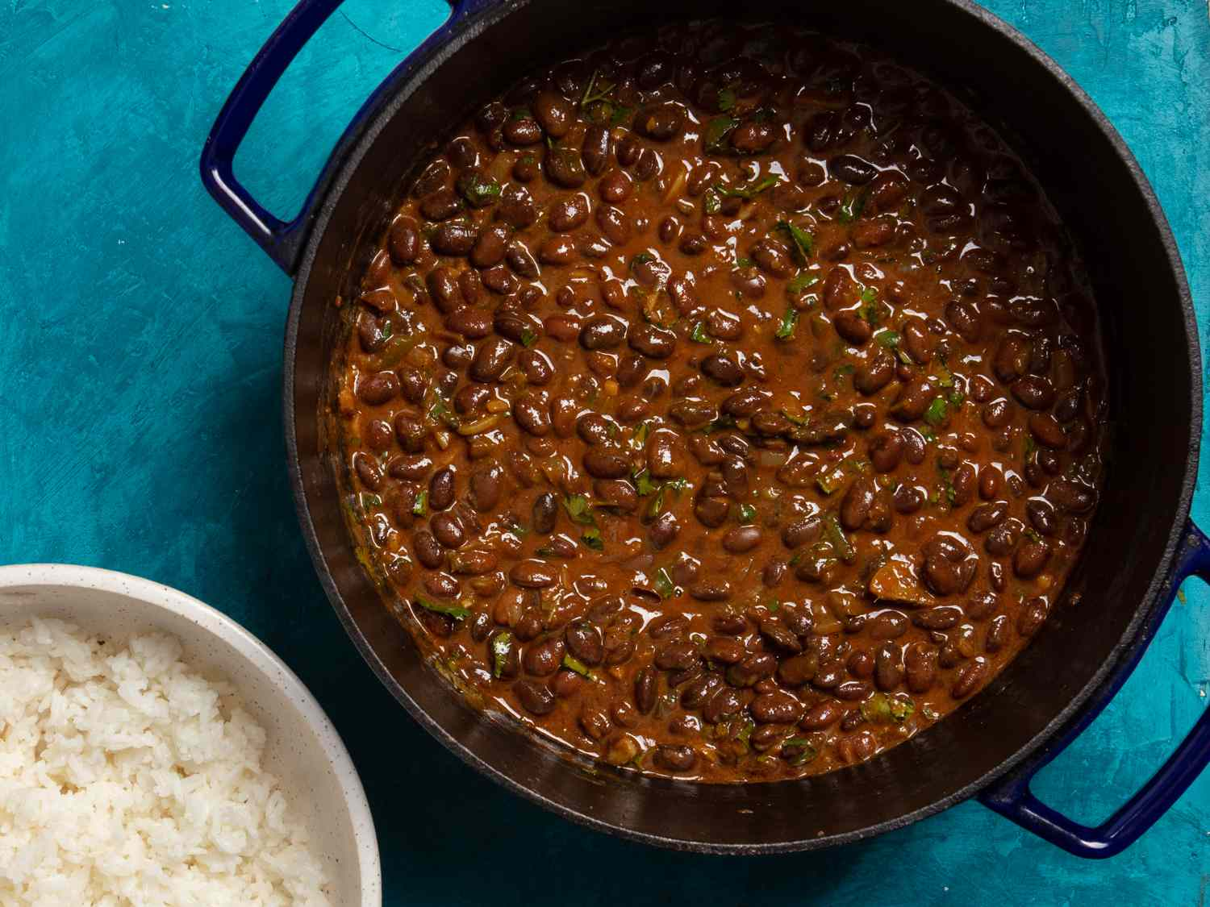
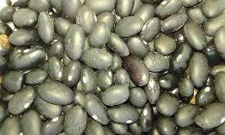
Overview
Highly nutritious, rich in protein, and preferred for soups, sauces, and processed foods. Tanzania’s black beans are clean, bold-colored, and well-sorted.
Specifications:
- Moisture: ≤ 13%
- Color: Deep black
- FM: < 1%
- Broken: < 3%
Key Markets:
- South Africa
- Asian processors
- Middle East
- Food manufacturers

D. SOYA BEANS (SOYBEANS)
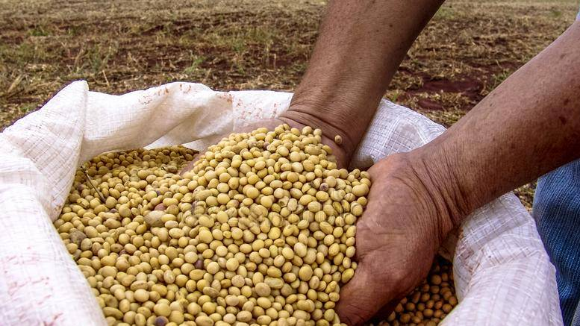
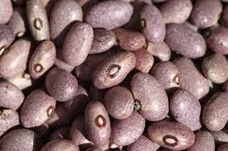
Overview
Tanzania produces competitive soybeans with good protein content, natural drying, and low foreign matter.
Used for:
- Oil pressing
- Animal feed
- Tofu & soy milk production
- Food industry applications
Specifications:
- Moisture: ≤ 13%
- Protein: 36–40%
- Impurities: ≤ 2%
- Oil Content: 17–20%
Key Markets:
- India
- China (select buyers)
- Zambia
- Kenya
- UAE

GLOBAL DEMAND & MARKET TRENDS
Key Export Destinations:
- India
- UAE
- Pakistan
- South Africa
- Rwanda
- Burundi
- DRC
- China (soybeans)
- Indian Ocean Islands
Trends:
- Food security programs increasing legume demand
- Growing plant protein consumption
- Strong demand for clean, naturally dried grains
- Attractive pricing vs Ethiopia/Zambia

HOW CROPLINK SUPPORTS BUYERS
✔ Verified sourcing
Direct from farmers, AMCOS, and commercial growers.
✔ Strict quality checks
- Moisture testing
- Sorting & cleaning verification
- Color and uniformity checks
- Defect control
✔ Proper storage & loading
- Ventilated warehouses
- Clean bags & pallets
- Professional container loading
- Bag-by-bag verification (on request)
✔ Full export documentation
- Phyto
- COO
- Fumigation
- Packing list
- Invoice
- BL instructions
✔ Weekly supply & seasonal contracts
Reliable for regular shipments across East Africa, Asia, and beyond.
We eliminate:
- High moisture
- Grain damage
- Poor sorting
- Mold or weevils
- Wrong grades

PACKAGING & SHIPMENT OPTIONS
Packaging:
- 25 kg PP bags
- 50 kg PP bags
- Custom printed bags (optional)
Container Capacities and Shipment Types:
- 20 ft container: 18–20 MT
- 40 ft container: 26–28 MT

CTA
Need today’s prices, photos, or sample specs?
Request Beans Prices & Specs →

MARKETS WE SERVE PAGE

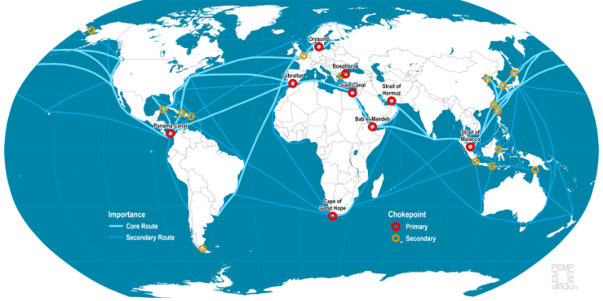



BANNER
Headline:
Connecting Tanzania’s Crops to Global Markets
Subtext:
We export high-quality agricultural products to buyers across Asia, Europe, the Middle East, and Africa supported by strong compliance, reliable logistics, and trusted sourcing networks.
CTA:
Request Market-Specific Price List

INTRODUCTION — OUR GLOBAL POSITION
CropLink operates at the intersection of farm-level sourcing, export logistics, and international trade workflows, enabling seamless movement of Tanzanian products to global buyers.
Our market footprint covers countries with high demand for:
- Pulses & oilseeds
- Nuts & kernels
- Spices
- Fresh horticulture
- Dry commodities
- Premium specialty crops

Buyers value us for consistency, transparency, compliance, and professional communication essentials in global trade.

REGIONS WE SERVE
Below is a detailed breakdown of all regions, what they buy, and why CropLink is trusted.

A. ASIA
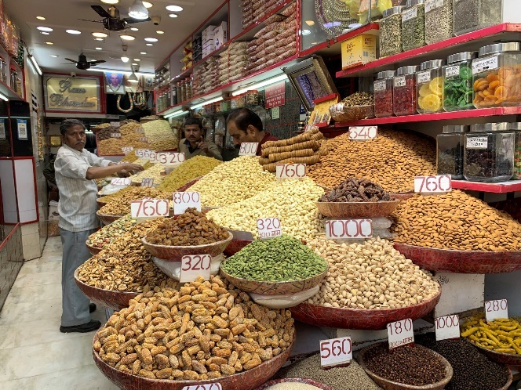

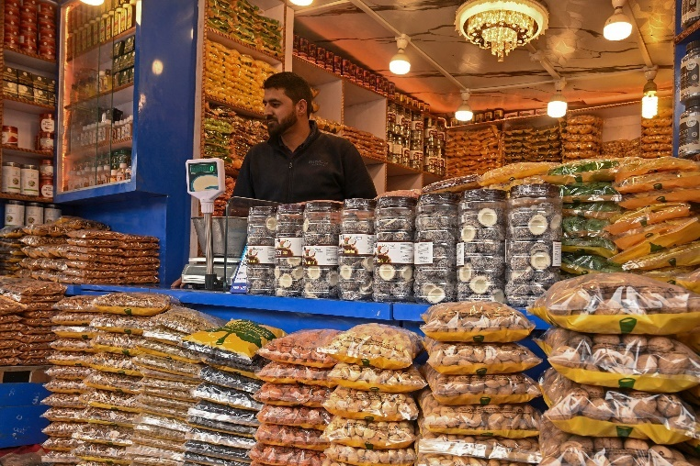

Asia is CropLink’s largest market cluster, driven by high consumption of pulses, spices, and oilseeds.
Key Countries We Serve
- India
- Pakistan
- Vietnam
- China
- Bangladesh
- Sri Lanka
- Malaysia
- Indonesia
Products in Highest Demand
- Sesame
- Pigeon peas
- Green moong
- Chickpeas
- Red kidney beans
- Groundnuts
- Black pepper
- Cardamom
- Cinnamon
- Coffee (select Asian markets)
- Cocoa (craft processors)

Market Dynamics
- India and Pakistan buy large volumes of pulses and sesame.
- Vietnam and China import sesame, groundnuts, and soya.
- Malaysia and Indonesia demand spices and cocoa.
- Asian buyers prioritize consistency, accurate grading, and moisture control — areas where CropLink excels.

MIDDLE EAST & GCC
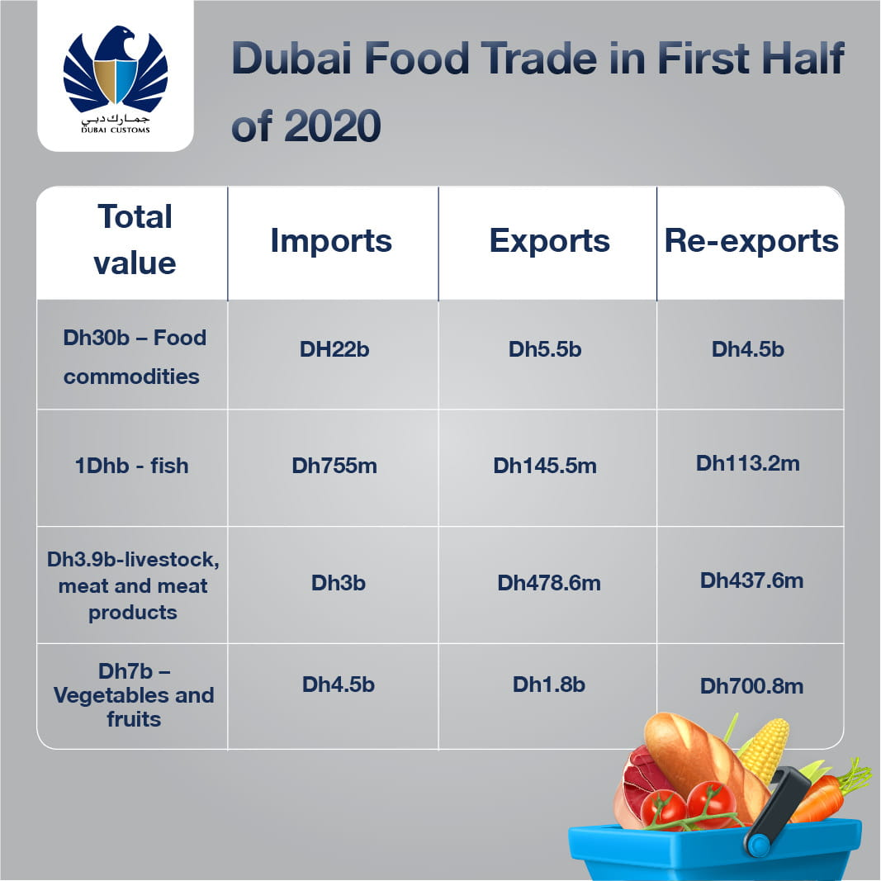
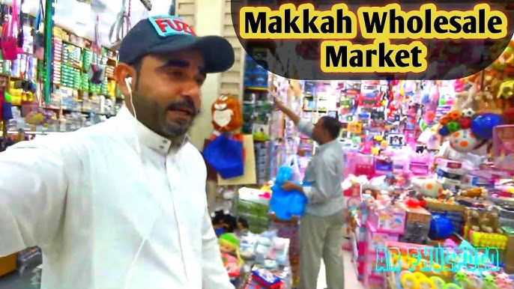
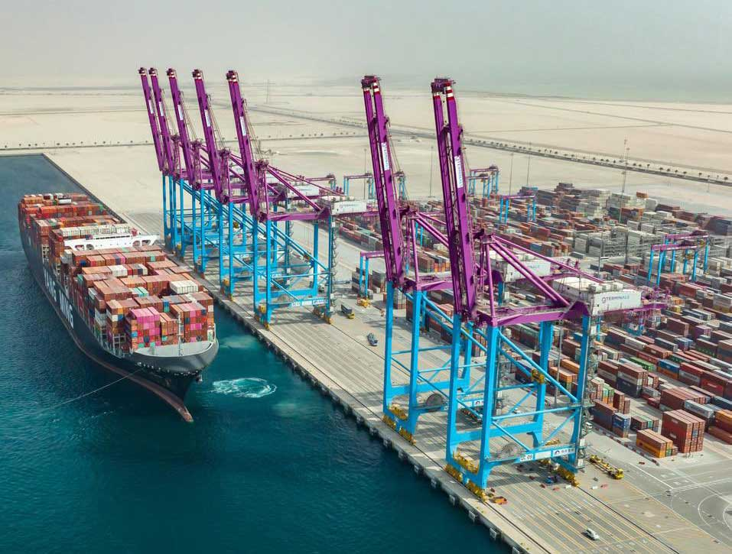

The Middle East imports Tanzanian crops at growing volumes due to strong food-processing industries and large diaspora communities.
Primary Destinations
- UAE
- Saudi Arabia
- Qatar
- Oman
- Kuwait
- Bahrain
Products in Highest Demand
- Beans (RKB, yellow, black)
- Sesame
- Pigeon peas
- Black pepper
- Cardamom
- Cloves
- Cinnamon
- Cashew kernels
- Avocado (fresh)
- Coffee
- Cocoa
Market Dynamics
- High demand for clean, well-sorted beans and spices.
- Strong purchasing power for premium grades.
- Fast clearance and efficiency are key which CropLink supports through strong logistics partners.
C. EUROPE

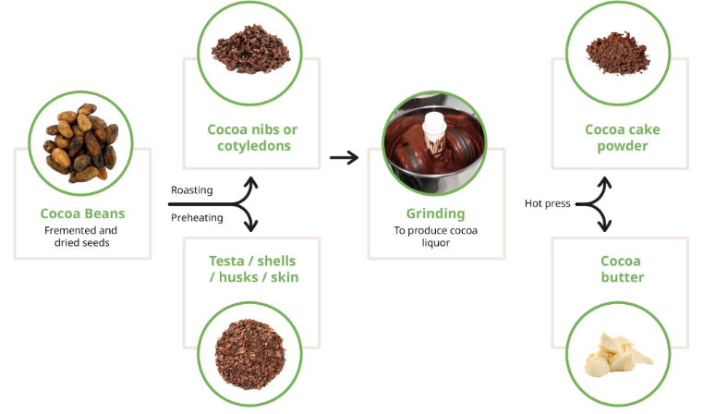

Europe values quality, traceability, and compliance above all making CropLink a natural fit.
Primary Destinations
- Netherlands (EU entry point)
- Germany
- France
- Italy
- Belgium
- Poland
- UK
Products in Highest Demand
- Coffee (Arabica & Robusta)
- Cocoa
- Avocado (Hass)
- Black pepper
- Cloves (select buyers)
- Sesame
- Specialty pulses
Market Requirements
- Phyto compliance
- Food safety documentation
- Traceability records
- Moisture and defect consistency
- Cold chain reliability (for horticulture)
CropLink understands these standards and integrates them into inspection and documentation workflows.

D. AFRICA (INTRA-AFRICA TRADE)
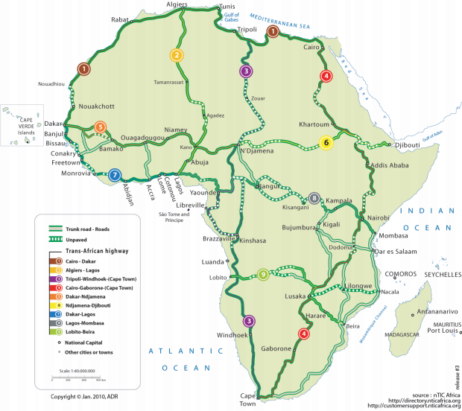

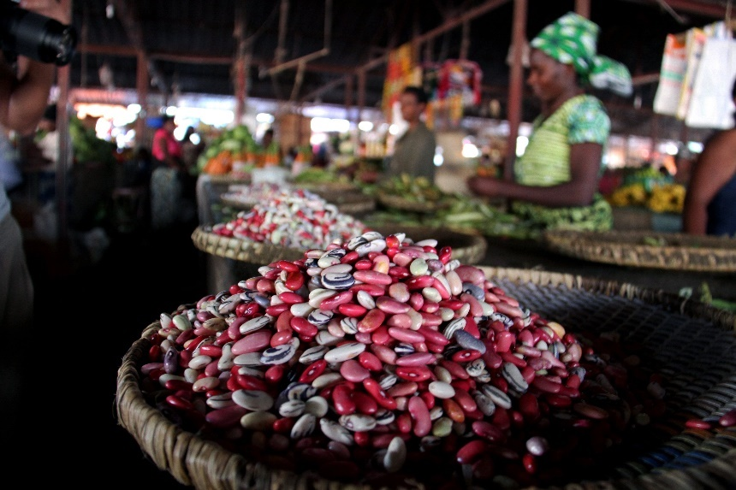

Africa’s intra-continent trade is rising, especially in regional food security markets.
Countries Served
- Kenya
- Uganda
- Rwanda
- Burundi
- DRC
- Zambia
- South Africa
- Mozambique
Products in Highest Demand
- Yellow beans
- Red kidney beans
- Black beans
- Soya beans
- Sunflower seeds
- Sesame
- Spices
- Pulses for relief programs
Why CropLink Fits Africa’s Market
- Proximity
- Competitive pricing
- Fast delivery
- High volumes
- Strong customs experience
CropLink also supports NGOs, development agencies, and food support programs with well-packed commodities.

WHY BUYERS CHOOSE CROPLINK
✔ Reliable Supply
Strong sourcing networks across Tanzania’s major producing regions.
✔ Accurate Grading
Every crop is inspected for moisture, purity, and uniformity.
✔ Transparent Communication
Buyers receive photos, videos, and sample confirmations before loading.
✔ Compliance Confidence
We coordinate peri-shipment inspection, fumigation, COO, and Phyto seamlessly.
✔ Logistics Strength
Handled via Dar es Salaam port with dependable shipping partners.
✔ Multi-Market Expertise
We understand the different standards and preferences of each region.
✔ Integrity in Execution
No shortcuts, no mixed grades, no surprises.

HOW WE SHIP (EXPORT LOGISTICS)
Shipping Options
- FCL (full container loads)
- Multi-crop shipments
- Cold-chain reefer containers (for avocado)
- Bulk-contract seasonal shipments
Container Capacities
- 20 ft: 16–20 MT (depending on crop)
- 40 ft: 24–28 MT
- Reefer 40 ft: 20–22 MT
Documents Handled by CropLink
- Invoice & Packing List
- Phytosanitary Certificate
- Certificate of Origin
- Fumigation Certificate
- Insurance (on request)
- BL instructions
- SGS/Bureau Veritas inspections (where required)

Buyers enjoy a smooth, predictable process from quotation to loading.

TRUST INDICATORS & MARKET REACH
Current Markets Served:
17+ countries (across Asia, Middle East, Africa, and Europe)
Product Portfolio:
12 different crops
(pulses, oilseeds, spices, nuts, horticulture, specialty crops)
Verified Producers & AMCOS:
40+ farmer groups and cooperatives
Shipments Handled:
Multiple seasonal containers across all main crops
Compliance Partners:
- TPHPA
- TRA
- TBS
- Crop Boards
- International inspection agencies
CropLink is building a footprint as Tanzania’s most trusted export partner for agricultural commodities.

CTA
Looking for country-specific prices, shipping options, or compliance details?
Request Market-Specific Export Guide →

PARTNERSHIPS & INSTITUTIONAL COLLABORATION

BANNER
Headline:
Working With Institutions to Strengthen Tanzania’s Agricultural Export Ecosystem
Subtext:
CropLink collaborates with ministries, crop boards, regulators, financial institutions, development partners, farmer organizations, and international buyers to ensure quality, compliance, and market growth across every stage of the export chain.
CTA:
Propose a Partnership

INTRODUCTION — OUR PARTNERSHIP PHILOSOPHY
CropLink believes that strong institutions build strong agricultural markets.
Every successful export transaction requires alignment between:
- Farmers and AMCOS
- Government regulators
- Laboratories and compliance agencies
- Development organisations
- Banks and trade financiers
- Port authorities & logistics providers
- International buyers
Our partnership model ensures transparency, compliance, and sustainable market growth creating value not only for our company, but for Tanzania’s entire agricultural ecosystem.
We do not operate as a merchant alone; we operate as a system builder.

OUR PARTNERSHIP FRAMEWORK
We collaborate across five strategic pillars:
Pillar 1 – Production & Farmer Linkages
Strengthening sourcing networks, training farmers on quality, and supporting AMCOS.
Pillar 2 – Compliance & Quality Assurance
Ensuring all crops meet international standards through regulatory collaboration.
Pillar 3 – Logistics & Trade Facilitation
Aligning with port, inspection, and customs agencies to ensure smooth export operations.
Pillar 4 – Finance & Trade Risk Management
Working with banks to enable safe, efficient, and compliant payment structures.
Pillar 5 – Global Market Integration
Building bridges between Tanzania and global buyers for long-term market access.
This is what makes CropLink a partner of institutions, not just a buyer of goods.

OUR KEY PARTNERS
Below is a detailed breakdown of the institutions we collaborate with and the role each plays.

A. MINISTRIES & GOVERNMENT AUTHORITIES
Strong alignment with government ensures that every export operates within national policy frameworks.
Primary Institutions We Work With:
- Ministry of Agriculture
- Ministry of Livestock & Fisheries (for compliance on oilseeds & exports)
- Ministry of Industry & Trade
- Ministry of Investment, Industry & Trade (MIIT)
- Local Government Authorities (LGAs)
- Regional Administration & Cooperative Offices
Collaboration Areas
- Farmer mobilization
- Crop quality improvement initiatives
- Export promotion programs
- Policy alignment & regulatory interpretation
- Support during peak export seasons
- Access to productivity datasets
CropLink aligns its operations with national policies, strengthening Tanzania’s export competitiveness.
B. CROP BOARDS & COMMODITY INSTITUTIONS
Crop boards are crucial for regulation, licensing, grading, quality monitoring, and documentation.
Crop Boards We Engage With:
- Cashewnut Board of Tanzania (CBT)
- Tanzania Coffee Board (TCB)
- Tanzania Tobacco Board (TTB)
- Tanzania Sisal Board
- Tanzania Cotton Board
- Tanzania Cooperative Development Commission (TCDC)
- Tanzania Trade Development Authority (TanTrade)
- Tropical Pesticides Research Institute (TPRI) – for fumigation & chemical compliance
- Tanzania Agriculture Research Institute (TARI) – technical and varietal guidance
Collaboration Areas
- Crop licensing & regulatory compliance
- Quality verification and grading support
- Market intelligence and pricing frameworks
- Inspection, testing, and certification
- Farmer cooperative strengthening
CropLink maintains active relationships with these bodies to ensure full compliance and clarity in every export.

C. REGULATORY & QUALITY ASSURANCE PARTNERS
Compliance is non-negotiable in global trade.
We collaborate closely with Tanzania’s regulatory ecosystem to meet international food safety and quality requirements.
Key Institutions
- Tanzania Bureau of Standards (TBS)
- Tanzania Plant Health & Pesticide Authority (TPHPA)
- Government Chemist Laboratory Authority (GCLA)
- Weighbridge and Measurement Bureaus
- TRA Customs Department
- SGS, Bureau Veritas, Intertek (optional pre-shipment inspection)
Areas of Collaboration
- Phytosanitary testing
- Aflatoxin & moisture testing
- Pre-shipment inspections
- Certificate of Conformity
- Export clearance
- Container handling safety
Compliance is one of CropLink’s strongest value propositions.

D. FINANCIAL INSTITUTIONS & TRADE FACILITATION PARTNERS
Smooth trade depends on strong financial relationships.
Banks & Institutions We Work With:
- CRDB Bank
- NMB Bank
- NBC
- Equity Bank
- Stanbic Bank
- Exim Bank
- Trade Finance Departments (LCs, TT payments, foreign exchange services)
Collaboration Areas
- Export financing
- LC processing
- FX settlements
- Payment risk management
- Buyer verification
- Structured commodity finance
CropLink ensures all transactions follow transparent, secure, and traceable financial procedures.

E. DEVELOPMENT AGENCIES & INTERNATIONAL PARTNERS
We collaborate with development partners who support agriculture, food systems, and trade facilitation.
Institutional Partners Include:
- USAID (agriculture & market systems programs)
- IFAD
- UNDP
- FAO
- UNIDO
- World Food Programme (WFP)
- East African Trade Facilitation Programs
- Agricultural NGOs

Areas of Collaboration
- Market systems strengthening
- Quality improvement at farmer level
- Inclusive supply chains
- SME export development
- Climate-smart agriculture promotion
- Post-harvest handling improvements
CropLink positions itself as a private sector anchor within large development projects.

F. LOGISTICS, PORT & TRANSPORT PARTNERS
We coordinate closely with logistics stakeholders to ensure smooth and reliable shipments.
Key Partners:
- Dar Es Salaam Port (TPA)
- Shipping lines (CMA-CGM, Maersk, MSC, PIL, etc.)
- Clearing & forwarding agents
- Warehouse operators
- Inspection teams
- Transporters across Tanzania
Areas of Collaboration
- Timely loading
- Accurate stuffing & sealing
- Vessel booking & scheduling
- Export documentation flow
- Cargo tracking and communication
With these partners, CropLink ensures zero-error shipments.

WHAT PARTNERSHIP WITH CROPLINK MEANS
We define partnership as shared value creation, not a transactional relationship.
Partnership With CropLink Delivers:
- Improved farmer incomes
- Stronger export compliance
- Expanded global market access
- Knowledge transfer & training
- Stable supply chains
- Transparency in operations
- Sustainable growth for all actors
- Reduced post-harvest losses

CropLink acts as a bridge between Tanzania’s agricultural potential and the global market’s requirements.

PARTNERSHIP MODELS WE OFFER
1. Institutional Collaboration Agreements
For ministries, crop boards, and regulatory bodies.
2. Market Access Partnerships
For foreign buyers and distributors seeking reliable, long-term supply.
3. Development Program Partnerships
Working with NGOs and donors on agriculture value-chain projects.
4. Financial Partnerships
Banks, fintechs, and trade finance entities supporting exporters.
5. Academic & Research Partnerships
For crop quality research, testing, and innovation.
6. Private Sector Value-Chain Partnerships
Buyers, processors, logistics companies, and cooperatives.

CTA
Ready to collaborate on strengthening Tanzania’s agricultural export sector?
Propose a Partnership →

CONTACT US FULL PAGE

BANNER
Headline:
Get in Touch With CropLink Solutions
Subtext:
Whether you’re requesting crop specifications, export quotations, compliance details, or partnership opportunities, our team is ready to support you.
CTA:
Send an Export Inquiry

HOW WE SUPPORT YOU
CropLink’s contact desk is designed for speed, clarity, and reliability.
We respond to inquiries from:
- International buyers
- Traders & distributors
- Processors
- Supermarkets
- Development partners
- Local institutions
- Farmer organizations
- Logistics partners
Our team handles:
- Price quotations
- Crop specifications & samples
- Export documentation
- Seasonal availability
- Compliance support
- Shipping schedules
- Partnership proposals
- Supplier verification
Every inquiry is managed by a dedicated export officer, ensuring fast and accurate communication.

CONTACT INFORMATION (FULL DETAILS)
📍 Head Office — Dar es Salaam, Tanzania
CropLink Solutions Limited
P.O. Box 66737, House No. 34, University Road, Survey
Dar es Salaam, Tanzania
📞 Phone
- +255 ___ ___ ___ (Primary Export Line)
- +255 714 955 004 (Director’s Office – Optional)
📧 Email
- info@croplinks.co.tz
- exports@croplinks.co.tz (Recommended for buyers)
🌍 Website
www.croplinks.co.tz
📦 Export Desk Hours
Monday – Saturday
8:00 AM – 7:00 PM (EAT)
Extended support for buyers in Asia & GCC.
📲 Social Media
- Instagram: @croplinktz
- LinkedIn: CropLink Solutions Limited
- Facebook: CropLink Solutions
(You can adjust when accounts are fully set.)

CONTACT FORM (TEXT PROMPTS)
This is what the website developer will use to build the form.
Form Title:
Send Us Your Inquiry
Fields:
- Full Name
- Company / Organization
- Country
- Email Address
- Phone / WhatsApp
- Select What You Need:
  - Price Quotation
  - Export Specifications
  - Seasonal Availability
  - Supply Contract
  - Partnership Opportunity
  - Supplier Verification
  - Other (Explain)
- Select Crop(s):
  - Cashew Nuts
  - Sesame Seeds
  - Pigeon Peas
  - Green Moong
  - Chickpeas
  - Sunflower Seeds
  - Groundnuts
  - Avocado (Fresh)
  - Cloves
  - Coffee
  - Black Pepper
  - Cardamom
  - Cinnamon
  - Cocoa
  - Beans (Red, Yellow, Black, Soya)
  - Mixed Container
- Estimated Quantity Required
- Preferred Shipment Month
- Your Message / Details
Button:
Submit Inquiry
After submission →
“Thank you. Our export team will get back to you within 12–24 hours.”

EXPORT INQUIRY PROMPTS (FOR BUYERS)
Below this section, we place guiding text to help buyers communicate clearly.
To speed up our response, include:
- Your destination country
- Crop and grade required
- Estimated quantity
- Packaging preference
- Shipment schedule
- Port of discharge
- Any inspection requirements
- Trade terms (FOB / CFR / CIF / FCA)
This reduces back-and-forth and ensures fast quotation delivery.

GOOGLE MAP / LOCATION EMBED
Add a Google Map showing:
- CropLink Headquarters, Dar es Salaam
- Nearest port: Dar Es Salaam Port (TPA)
This builds trust for foreign buyers.

CTA
Ready to receive today’s export prices, specifications, or shipment timelines?
Send an Export Inquiry →

FULL & DETAILED FOOTER CONTENT

FOOTER STRUCTURE (4–5 COLUMN LAYOUT)
Column 1: Company Identity & Summary
Column 2: Quick Links
Column 3: Our Products (Crops)
Column 4: Our Services
Column 5: Contact & Compliance Info
Optional bottom strip: Legal & Compliance Disclaimer

COLUMN 1 — COMPANY IDENTITY & SUMMARY
CROPLINK SOLUTIONS LIMITED
Empowering Tanzania’s Agricultural Exports
We source, process, and export high-quality agricultural products from Tanzania to global markets.
From farm-level sourcing to documentation, quality checks, and shipping, we ensure every client receives reliable, compliant, and market-ready goods.
Trusted by buyers across Asia, Middle East, Africa & Europe.
Registered in Tanzania
TIN: 182-963-534
Business License: BL01396912024-2500027763
Export License: B.L.No: 20000086626

3. COLUMN 2 — QUICK LINKS
- Home
- About Us
- Services
- Our Crops
- Markets
- Partnerships
- Contact Us
- Request a Quote
- Supplier Verification Request

COLUMN 3 — OUR PRODUCTS (CROPS)
- Cashew Nuts
- Sesame Seeds
- Pigeon Peas
- Green Moong
- Chickpeas
- Sunflower Seeds
- Groundnuts
- Avocado (Fresh Hass)
- Cloves
- Coffee
- Cocoa
- Black Pepper
- Cardamom
- Cinnamon
- Beans (Red, Yellow, Black, Soya)
- Mixed Containers
(Add link to each crop page.)

COLUMN 4 — OUR SERVICES
- Sourcing & Procurement
- Export Management
- Quality Inspection & Grading
- Documentation & Compliance
- Logistics & Shipping Coordination
- Supplier Verification
- Buyer Support & Reporting
- Product Branding & Market Promotion
- Crop Advisory Services
- Contract Supply Programs
Each can link to its detailed service page.

COLUMN 5 — CONTACT & SUPPORT
📍 Head Office (Dar es Salaam)
CropLink Solutions Limited
P.O.Box66737, House No. 34, University Road, Survey
Dar Es Salaam, Tanzania
📞 Phone
+255 ___ ___ ___
+255 ___ ___ ___ (WhatsApp available)
📧 Email
info@croplinks.co.tz
exports@croplinks.co.tz
🌍 Website
www.croplinks.co.tz
⏰ Working Hours
Mon – Sat: 8:00 AM – 7:00 PM (EAT)
Extended support for Asia & GCC buyers.
📲 Social Media
Instagram | LinkedIn | Facebook

OPTIONAL COLUMN / FOOTER STRIP — CERTIFICATIONS & INSTITUTIONAL LINKS
(Use logos)
- Tanzania Bureau of Standards (TBS)
- Tanzania Plant Health & Pesticides Authority (TPHPA)
- Tropical Pesticides Research Institute (TPRI)
- TRA Customs
- Crop Boards (Cashew, Coffee, etc.)
- SGS / Bureau Veritas (Inspection partners)
Small caption:
All exports are processed in compliance with Tanzania’s regulatory authorities & international food safety requirements.

LEGAL & COMPLIANCE DISCLAIMER (BOTTOM STRIP)
© 2025 CropLink Solutions Limited. All Rights Reserved.
All exports comply with TPHPA, TBS, TRA, port regulations, and destination-country import requirements.
Product availability, grading, and pricing may vary by season and global market conditions.
CropLink does not engage in any transactions without proper documentation, verification, and regulatory clearance.
CALL-TO-ACTION (Bottom Bar)
Looking for today’s market prices or shipment schedules?
👉 Request a Quote
(Or)
👉 Contact the Export Desk

